Pita bread crisps

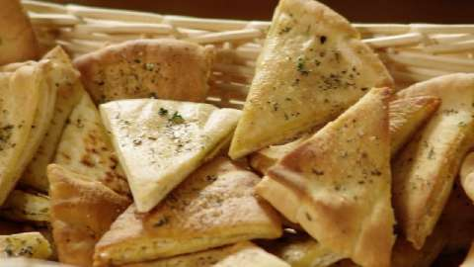

2 packets of pita bread
5 teaspoons ground sumac
Fresh herbs – Rosemary/Sage/Thyme/Oregano, Marjoram, etc
¾ cup Olive Oil (enough to mix with sumac and herbs to brush onto bread)

- Method

- Cut pita bread into 8 triangles from each round
- Wash and remove herb leaves from stalk and finely chop.
- Combine olive oil, chopped herbs and sumac in mixing bowl
- Place pita bread triangle on tray lined with baking paper
- Brush bread with oil and herb mixture.
- Bake at 180°C until crisp and golden brown.
- Serve with dip.

