Pizza with Warrigal Greens, Garlic & Herbs

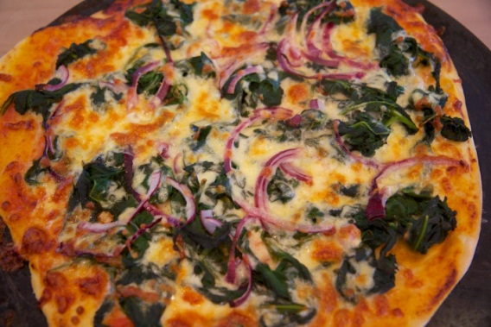

Topping
2 x pizza bases
200g warrigal greens, leaves only
12 assorted leaves (silverbeet, kale, spinach, etc.) finely chopped
½ cup oil
2 clove garlic, crushed
250g mozzarella
2 teaspoon chopped rosemary
2 teaspoon chopped oregano
2 tablespoon chopped parsley
60g parmesan, grated

Method
- Spray pizza trays with cooking oil. Place bases onto greased trays.
- Boil small saucepan of water for warrigal greens. Wash warrigal greens and remove leaves from stems.
- Blanch the warrigal greens in boiling water for 3-4 minutes.
- Peel and crush garlic.
- Drain warrigal greens and run under cold water. Drain again and squeeze out all excess water. Chop finely.
- Wash assorted leaves, remove leaves from the stalks and finely chop.
- Grate mozzarella cheese and parmesan cheese. Keep the two cheeses separate.
- Wash herbs, remove leaves from stalks and finely chop herbs. Keep herbs aside for topping the pizza.
- Heat oil in a fry pan, add crushed garlic and cook for 30 seconds. Add chopped warrigal greens and assorted leaves and fry until wilted.
- Scatter greens over pizza base. Top with mozzarella, herbs and parmesan. Add a little salt and pepper and then drizzle with a little bit more olive oil.
- Bake for 15-20 minutes or until crisp and golden.

