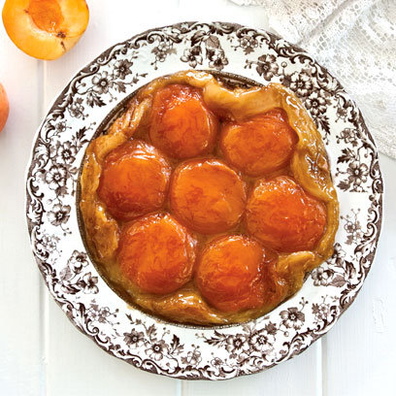
Apricot Tarte Tatin
You will need
2 medium tin of apricot halves
2 sheets puff pastry
150g caster sugar
80g butter, melted
Method
1. Preheat the oven to 190ºC/gas mark 5. If you are using tinned apricots, drain and let them dry on some paper towel. You want them to be as dry as possible. If using fresh apricots halve and deseed them, then place them on paper towel.
2. Place a 20 centimetre oven-friendly non-stick frying pan over a medium heat and scatter half of the sugar over the base. Once the sugar starts to caramelise, add the rest of the sugar and stir until it has all melted and is a lovely, golden caramel colour.
3. Add melted butter and whisk to combine, making a caramel. Don’t worry if it splits, keep going. Take the pan off the heat and place as many apricots (curved side down) as will fit neatly over the base of the pan.
4. Using a knife, cut a circle of puff pastry that is slightly bigger than the frying pan used for the caramel. Score the middle of the pastry so that the steam can escape. Cover the pan with puff pastry and tuck the edges in. Bake in the oven until the pastry is golden brown and puffed up, approximately 20 to 25 minutes. Take out of the oven and let it stand for a few minutes.
5. To serve, place a plate that is larger than the pan over the top and then carefully turn the tart upside down, so that it lands on the plate. Remove the pan gently and be careful of the hot caramel as it can burn you.

