Black Bean Dip
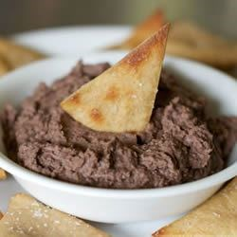
2 cans black beans, rinsed and drained
1/2 cup chopped brown onion
1/3 cup chopped cilantro
2 clove garlic, crushed
2 tablespoons fresh lime juice
1/4 teaspoon ground cumin
1/4 teaspoon chili powder
1/2 teaspoon sea salt
1/4 teaspoon black pepper

DIRECTIONS:
- Open cans of black beans, drain them in a strainer and rinse them.
- Peel onion and finely dice. Peel and crush garlic.
- Lightly fry onion and garlic in a small amount of olive oil without it going brown.
- Wash and chop coriander leaves.
- Cut lime in half and juice 1 half. Measure the juice needed for the recipe. Juice the second half of the lime if more juice is needed.
- Put the black beans, onion, cilantro, garlic, lime juice, cumin, chili powder, salt, and black pepper in a food processor or blender. Blend until smooth.
- Pour the black bean dip in a bowl.
- Serve with pita bread or corn chips.
It goes well with salsa and guacamole as a layer dip!

