Brandy Snap Baskets
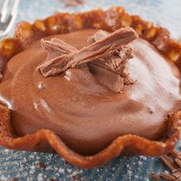

- Ingredients
- 50g butter, chopped
- 1/3 cup (70g) brown sugar
- 1/4 cup (60ml) golden syrup
- 1/3 cup (50g) plain flour
- 1 teaspoon ground ginger

- Method
- Step 1
Preheat oven to 180°C. Line a tray with baking paper. Combine the butter, brown sugar and golden syrup in a saucepan and cook over medium heat, stirring, for 2-3 minutes or until butter melts and sugar dissolves. Set pan aside for 5 minutes to cool slightly.
- Step 2
Add the flour and ginger to the mixture and stir to combine. Drop four teaspoonfuls of mixture on to the tray, spaced well apart. Bake for 5 minutes or until they are bubbling and have spread to 10cm in diameter.
- Step 3
Remove from oven and allow to cool for 1 minute. Working quickly, use a palette knife to lift each one and onto upside down coffee cups or moulds and press down around the edges to form a basket.
- Step 4

Leave to set for 1 minute, gently slip off the mould and transfer to a wire rack. Repeat with remaining mixture.

Chocolate Mousse
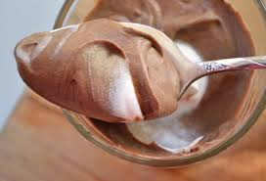
- Ingredients
- 1 1/2 cup pure cream
- 375g mascarpone
- 1 ½ teaspoon vanilla extract
- 3 teaspoon icing sugar mixture
- 3 tablespoon Dutch cocoa

- Method
- Notes
- Step 1
Using an electric mixer, beat cream, mascarpone, vanilla, icing sugar and cocoa for 2 to 3 minutes or until thick and creamy (don't over-mix).
- Step 2
Spoon mousse mixture into a large piping bag fitted with a star shaped nozzle. Keep in fridge until ready to serve.

- Step 3 Pipe mousse into brandy snap baskets. Serve

