Chickpea & Broad Bean Salad
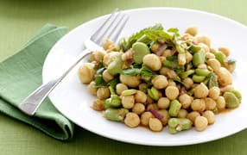

Ingredients

- 500g frozen podded broad beans (use fresh if available or some fresh and some frozen)
- 2 x 400g can chickpeas, drained
- 1 small red onion, finely diced
- 2 garlic cloves, crushed
- 1 tablespoon cumin, ground
- 1 tablespoon coriander, ground
- 1 tablespoon paprika
- 1 tablespoon extra-virgin olive oil
- 1 tablespoon soy sauce, reduced-salt
- 2 lemons, juice only
- ½ cup pepitas/pumpkin seeds, toasted
- ½ cup parsley leaves, torn
- ¼ cup mint leaves, torn
- Salt, pepper

Method
- Cook the broad beans in a large pan of boiling water for 7 minutes, then drain and refresh under cold water. Drain again and slip off the grey skin from each bean.
- Peel and dice red onion. Peel and crush garlic cloves. Juice lemons.
- Toast pepitas in a frying pan until golden brown.
- Wash parsley and mint. Remove leaves from stems and tear leaves into small pieces.
- Mix everything together except the herbs and pepitas and leave to marinate for 20 minutes. Taste and adjust salt and pepper to taste.
- Mix in the pepitas and the herbs then serve.

