Creamy Cauliflower Dip

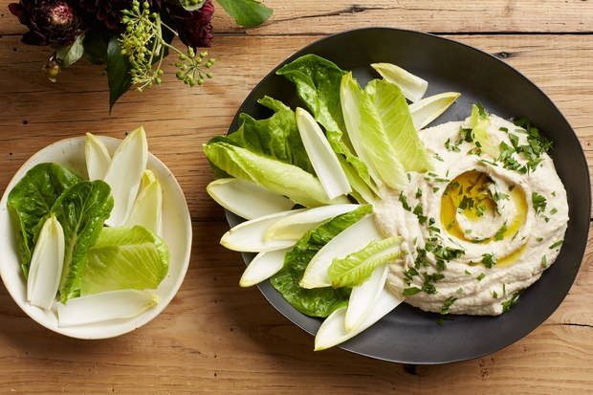

INGREDIENTS
  - 1 medium head of cauliflower, florets and stem cut into 1-inch pieces
  - 1 garlic clove, peeled
  - 1/4 cup olive oil, divided, plus more for serving
  - 1 medium onion, thinly sliced
  - 1 teaspoon ground cumin
  - 2 teaspoons sea salt, divided
  - 3/4 cup plain Greek yogurt
  - 1 teaspoon finely grated lemon zest
  - 3 tablespoons fresh lemon juice
  - Coarsely chopped parsley (for serving)

PREPARATION
  - Pour water into a medium saucepan to a depth of 1/4"; add cauliflower and garlic. Cover, bring to a boil over high heat, and cook until florets are very easily pierced with a paring knife, about 10 minutes. Drain and set aside.
  - Meanwhile, heat 2 Tbsp. oil in a large frying pan over medium. Add onion, cumin, and 1 tsp. salt and cook, stirring often, until onion is translucent, about 3 minutes. Increase heat to medium-high and cook, stirring often, until onion is golden brown, about 5 minutes more.
  - Transfer onion mixture to a blender. Add yogurt, lemon zest and juice, reserved cauliflower, and remaining 1 tsp. salt and purée until smooth.
  - With the motor running, add 2 Tbsp. oil in a steady stream until well combined. If dip is too thick, blend in 1 Tbsp. water at a time to reach desired consistency. Let cool to room temperature.
  - To serve, spread dip in a wide bowl or platter. Drizzle with oil and top with parsley.
  - Serve with warm pita bread triangles.

