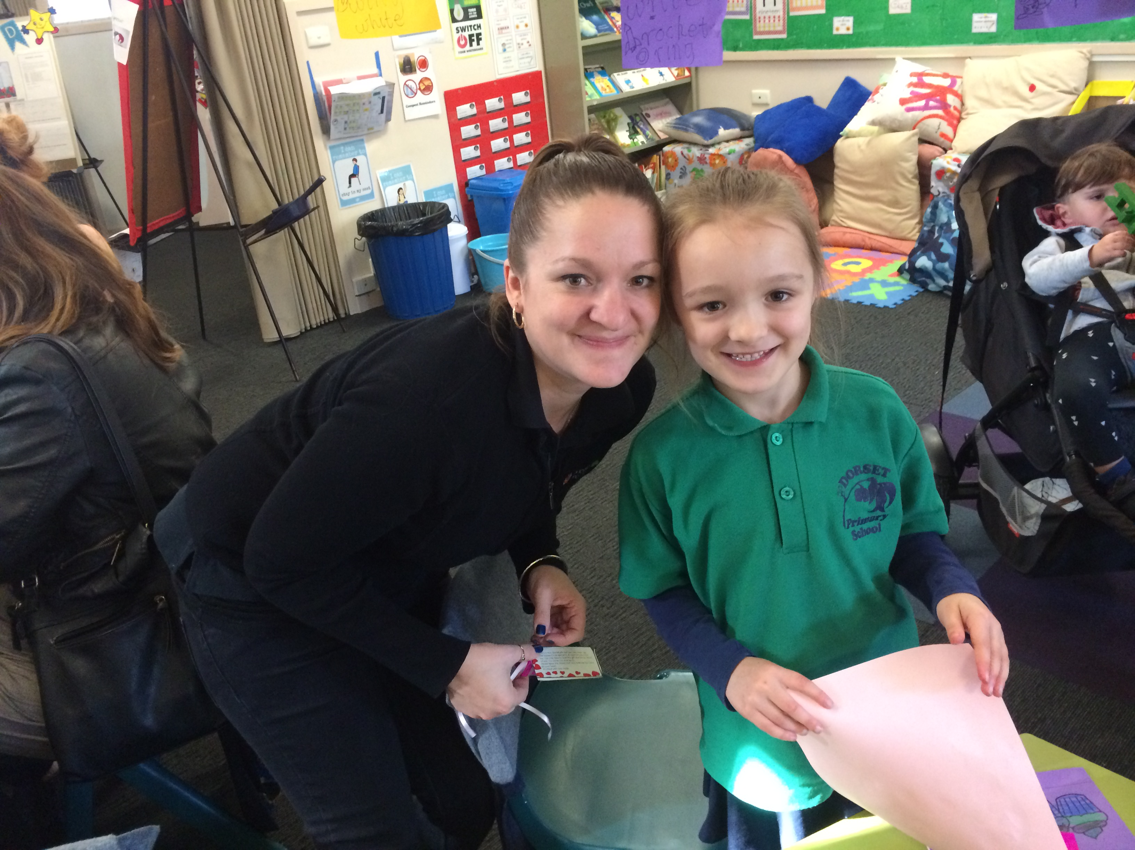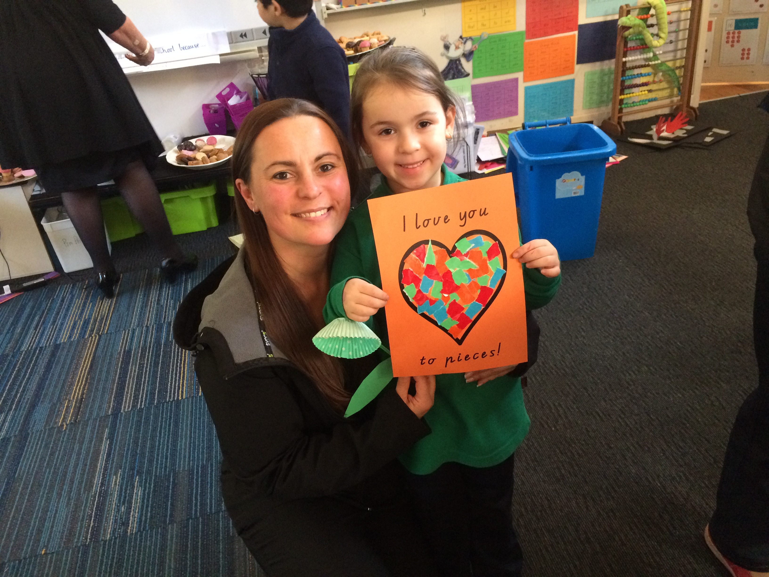

***Mother’s Day***

The Foundation students would like to wish all their Mothers and special people a Happy Mother’s Day. We enjoyed having them come to school on Friday for activities and a special afternoon tea.

In our classrooms, our special people helped the students to complete four different craft activities: a flower, a heart, a present and “love hands”. We then went to the hall to sing special songs and have an afternoon tea of biscuits and cordial.

***TIMETABLE***

Monday – LRC (Library), LOTE, Music, PMP

Tuesday – Physical Education

Wednesday – Cooking, PMP

Thursday - Art

***Cooking***: (Please note: Changes may occur)

|  |  |
| --- | --- |
| Week 5 | NO COOKING |
| Week 6 | Make a sandwich |
| Week 7 | Icing Biscuits |

***Coming Up:***

**Tuesday 16th May – Education Week**

**Open Day – 2.00-3.00pm**

**Open Night – 7.00-8.00pm  
Wednesday 17th May – Curriculum Day**

**Thursday 18th May – Arts Day**

***In Maths:***

In Week 4, we celebrated 50 Days of School on the 4th of May. During our Maths block, the students completed a Maths rotation where our grades moved from room to room, participating in a different 50-themed activity with each teacher. These included: number 50 fitness with Mr. Wilkinson, cutting a straw into 50 pieces with Mrs. Quigg, stamping 50 times on numbers with Mr. Seymour and writing and tracing the number 50 fifty times with Mrs. Lawley.

The Foundation students have started to practise measurement by comparing objects that are longer or shorter as well as measuring their height using different objects.

We have also looked at different ways to represent numbers; such as numerals, groups of objects and on a “rekenrek”.

***In Literacy:***

Our students have started to consolidate their letter/sound knowledge and use this to build and recognise words. We are now beginning to look at simple blended sounds such as “bl” and “br” as well as building “_et” and “_at” words using “Onset & Rime.”

We are in the process of introducing a “Reading Group” rotation into our morning literacy block. In small groups, students will complete one of four activities each day including: teacher guided, word-building activities, letter-knowledge activities and using the iPads.

We are impressed with the work students are putting into learning their “Magic Words” at home. We would like to remind parents that students are to focus on practising their correct level; ***not all pages.*** If you are unsure of which Magic Word level your child should be practising, please see their teacher.

The Foundation students have been practising writing letters in Victorian Modern Cursive Handwriting. In the past two weeks, we have focused on the “straight letter” family (i, t, j, l, f). We have used our whiteboards to practise writing these letters on dotted thirds.

Our Show and Share topics so far this term have linked into our Integrated topic of “What’s it made of?” The students have done an excellent job of sharing things that are made of wood or plastic. This week, we will look at objects made of metal. Next week, we will link into our new text type of “explanation” by having students explain how something works.

We hope that our students are continuing to use Reading Eggs at home by using the password located in their reader cover.

**Foundation News**

**15th May, 2017**

sCHOO

