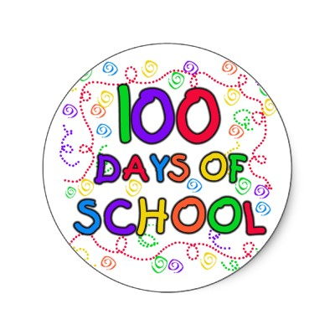

***SHOW AND SHARE TOPICS***

Week 5 – Bring a photo of yourself and tell us about it.

Week 6 - Bring a toy, picture or drawing showing a

character from a book or movie

Week 7 - Present your favourite scene from a movie.

***TIMETABLE***

Monday – LRC (Library), LOTE, Performing Arts, PMP

Tuesday – Science, Physical Education (FA, FB, FC)

Wednesday – Cooking, PMP

Thursday – Physical Education (FD), Performing Arts (Snakes- blue group)

***Coming Up:***

**August 16th** – Excursion to Royal Botanic Gardens

**August 30th** – Book Parade

**September 1st** – Father’s Day Stall

J

***Cooking***:(Please note: Changes may occur)

|  |  |
| --- | --- |
| Week 5 | No cooking (due to excursion) |
| Week 6 | Pasta salad |
| Week 7 | Nachos |
| Week 8 | Biscuits |



***100 Days of School***

As part of our celebration for

100 Days or School, our Parents,

Grandparents and Special Persons

participated in our ‘show and share’ session and talked about what it was like when they went to school. Students shared groups of one hundred such as 100 straws, 100 Nutrigrain, 100 buttons, 100 beads and many more interesting items. Our visitors assisted in completing our 100 Days of School newspaper.

We then had our picnic morning tea with our visitors. Thank you so much for supporting this special occasion making it a memorable event. As we have said previously, w*e are very proud of our students’ progress and success over the past 100 days at school and we look forward to celebrating this exciting milestone!*

***In Maths:***

Last week we learnt about Mass. The students compared common objects in length, mass and capacity using appropriate language (e.g. *longer*, *wider*, *heavier, lighter, holds more or less).*

This week we have revisited addition.

The students identify addition by

putting groups of objects together

and counting the combined set.

Materials are used for hands on learning

experiences to support and explain the strategies used to show addition.

***In Literacy:***   
The students are developing strategies to support their accuracy in reading and understanding of the text.

In Writing, we have been focusing on Information Reports, exploring the following topics, ‘School’ and ‘Plants’. The students have a good understanding of the features and structures in writing an Information Report.

The students look forward to Friday Free Writing with great enthusiasm. We encourage the students to think about their ideas to write about. Many students bring writing prompts which we can stick into their books.

Over the next few weeks, some students will be using dotted third writing books. Our focus has been to write on the base line, using correct letter size and letter formation.

**Wow! We have really progressed since the beginning of the year.**

In our classes we have introduced Spelling Books. The students identify ‘tricky’ words in their writing. These are correctly spelt and are used as their personal weekly spelling words. Throughout the week we practise writing the words using the process, Look, Say, Name, Cover, Write and Check.

Already we are in Week 4 of Term 3 and the students have had a very busy start to this term.

The highlight so far has been our ‘100 Days at School’. All students received their certificate, which was presented by Mrs. Coppa.

J

**Foundation News**

**11th August, 2017**

sCHOO

