Green Frittata
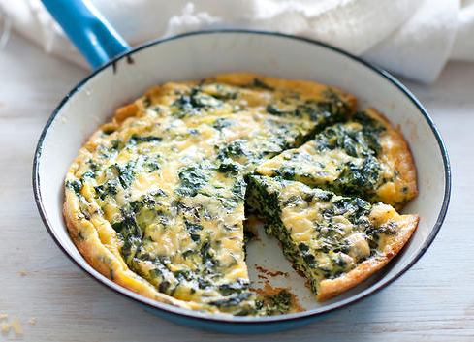
Ingredients
½ onion | 2 cloves garlic
6 stems of silverbeet or rocket (or a combination of both) | 6 stems of kale
1 teaspoon pink salt | 6 stems parsley
12 eggs | pepper
½ cup olive oil
Method
- Peel and chop the onion and garlic finely. Wash the silverbeet/rocket and kale.
- Remove leaves from the stems and finely shred the leaves.
- Transfer the green vegetables into a large bowl. Remove stems from parsley, chop the parsley leaves and add to the large bowl.
- Into a smaller bowl, crack the eggs and beat with a whisk, adding a pinch of salt and a pinch of pepper. Pour ¼ cup of oil into a 24cm non-stick frying pan and place over medium heat.
- Add the onion and garlic and fry, stirring with a wooden spoon, for 5 minutes. Tip the onion and garlic into the bowl with the green vegetables. Add the whisked eggs and stir well.
- Wipe out the pan with paper towel, then add the remaining ¼ cup oil over a high heat. When the oil is hot, carefully pour the mixture into the pan. The mixture should puff at the edges as soon as it hits the pan.
- Reduce heat to low and cook for 5 minutes or until the bottom is golden brown (use an egg lifter to check). The top should still be moist.
- Using a round pizza tray slightly larger than the pan, sit it on top of the pan, then carefully tip the pan over to invert the frittata onto the plate.
- Carefully slide the frittata back into the pan so that the cooked side is facing up. Cook for another 5 minutes, or until the bottom is golden
- Cut into enough squares for the class to taste and serve.

