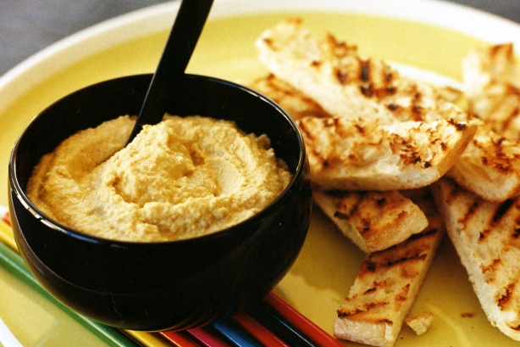
- 600g canned chickpeas, drained, rinsed
- 3 garlic cloves, crushed
- 100ml olive oil
- 2 tablespoons tahini (sesame seed paste)
- 1 teaspoon ground cumin
- Juice of 2 lemons (add to taste)
- 1/4 cup (60ml) water

- Step 1
Place the chickpeas, garlic, olive oil, tahini paste, cumin and lemon juice in a food processor and process until combined. Add 1/4 cup (60ml) of water and process again until quite smooth.
- Step 2
Place hummus in a bowl and serve with falafel, pita bread and tabbouleh

