Jerusalem Artichoke Soup
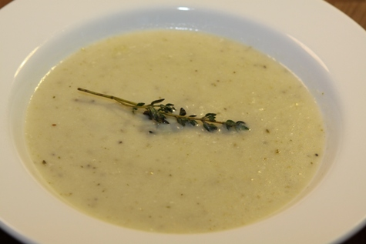
3kg Jerusalem artichokes
Olive oil
150ml non alcoholic white wine
6 Garlic Cloves
3 brown onions
2 celery sticks
3 tablespoons fresh thyme leaves
3 litres vegetable or chicken stock
Salt, pepper
100ml cream
Fresh thyme leaves, to serve

Method:
- Peel and finely dice onions.
- Peel and slice garlic. Dice celery
- In a heavy based large pot, heat olive oil.
- Gently fry celery, thyme, onion and garlic until soft and transparent.
- Wash, scrub and roughly chop Jerusalem artichokes.
- Add white wine to pot cook for 1-2 mins or until wine is absorbed.
- Add Jerusalem artichokes.
- Cook for 5 minutes to combine all the vegetables.
- Season with salt and pepper
- Add stock to pot to cover vegetables and simmer until artichokes are soft.
- Puree with stick blender or food processor starting with the solids and then add liquid gradually until desired consistency is achieved.
- Pass through a strainer and return to the pot.
- Add the cream and heat through.
- Taste and adjust salt and pepper (seasoning) to suit your taste and serve with bread (dinner rolls, etc)

