Jerusalem Artichokes with Crispy Prosciutto
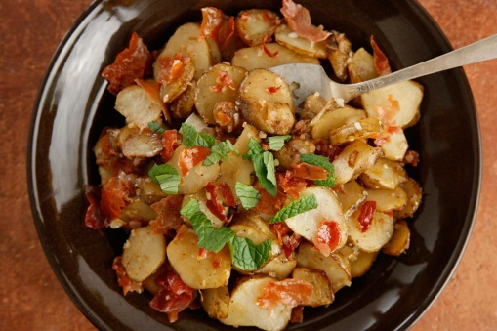

INGREDIENTS
- 4 tablespoons olive oil
- 100g thinly sliced prosciutto
- 1kg Jerusalem artichokes
- Salt
- 120mls water
- 2 shallots
- 4 teaspoons mint leaves
- ½ lemon
- ¼ - ½ cauliflower
- Grated parmesan
- Rocket/roquette leaves

INSTRUCTIONS
- Wash, scrub and slice Jerusalem Artichokes. Heat 1 tablespoon of the oil in a large frying pan over medium heat until shimmering. Add the prosciutto in a single layer (you may have to do this in batches) and cook until crisp, about 3 to 5 minutes.
- Remove from the pan to a paper-towel-lined plate and let cool slightly. Crumble and set aside.
- Cut cauliflower into small pieces and toss in a mixing bowl with enough olive to coat the pieces and salt and pepper. Spread onto a tray lined with baking paper.
- Bake at 200°C for 25-30 minutes or until golden brown. Remove from oven and sprinkle with parmesan.
- Return the pan to medium heat and add the remaining 1 tablespoon oil.
- When the oil shimmers, add the Jerusalem artichokes, season with salt, and cook, stirring occasionally, until browned and almost fork tender, about 15 minutes. Peel and finely chop shallots.
- Add the water, stir gently to release any browned bits from the bottom of the pan, and cook until the water evaporates and the artichokes are fork tender, about 3 minutes. Add the shallot and cook until golden, about 3 minutes more. Wash and finely shred mint leaves. Juice lemon.
- Wash rocket leaves, drain well and then tear into small pieces.
- Stir in the crumbled prosciutto, roasted cauliflower, rocket leaves, mint, and lemon juice, adjust the seasoning as needed, and serve immediately

