Lemon and Kaffir Lime Curd
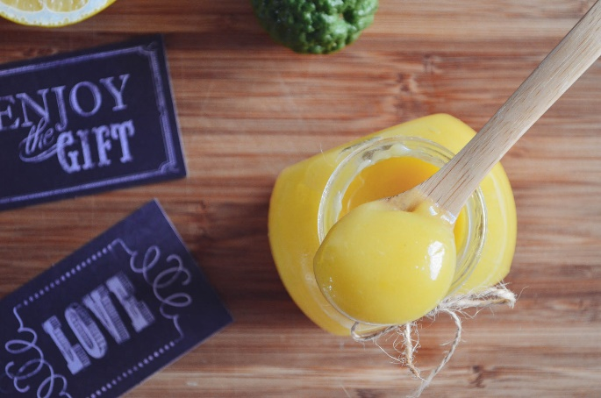

ZEST OF 1 LEMON AND 2 KAFFIR LIMES

1/2 CUP SUGAR

50G UNSALTED BUTTER

2 LARGE EGGS

1/2 CUP LEMON JUICE

JUICE OF 2 KAFFIR LIMES

PINCH OF SALT
- Place the zest and sugar in a food processor and blend until fine.
- In a mixer with the paddle attachment, beat the butter and sugar & zest mixture at medium speed until light.
- Turn the speed to low and add the eggs one at a time, beating well after each addition.
- Add in the lemon and kaffir lime juices and salt. Beat well.
- Transfer the mixture to a heavy bottom saucepan. Cook over the lowest heat, stir continuously with a wooden spoon for about 10 minutes or until the mixture is just thick to coat your spoon.
- Cool, pour into sterilized jar/s and refrigerate. Label the jar with the date.

