Luscious Lemon Curd Tarts
Quick and easy tarts made with store bought or homemade lemon curd and butternut snap biscuits. These are topped with a lemon curd, cream cheese frosting. You will need a 1/2 round patty cake tin to make these.

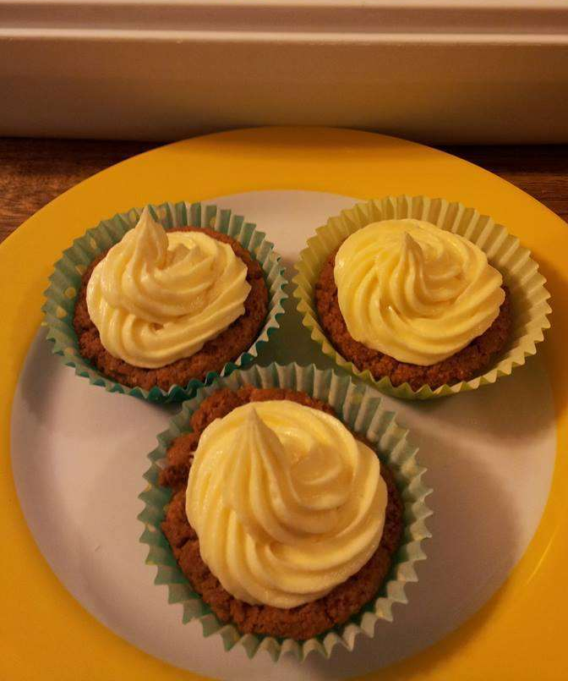

Ingredients
- 2 packets butternut snap biscuits
- 226g butter, softened
- 125g cream cheese, softened
- 120g lemon curd
- 4 1/2 cups icing sugar
- extra lemon curd, as needed

Directions

Preheat oven to 170 degrees C. You will need 1/2 round pattycake tins.
- Lay biscuits over holes of tins and place in oven until soft, around 5 minutes.
- Remove from oven and quickly press biscuits into holes so you have a tart shape. Cool.
- With an electric mixer, beat butter until creamy.
- Add cream cheese and lemon curd, beating until smooth.
- Add icing sugar in 3 batches, beating until well combined.
- Using the extra lemon curd, place a teaspoon of curd into each biscuit.
- Pipe or cream cheese mix over top.
- Refrigerate until needed.

