Melon soup with prosciutto
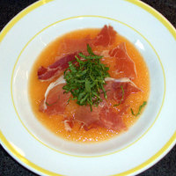
Ingredients
* 2 Medium Cantaloupes or other melon (About 8 cups; Peeled, Seeded and Cut into Chunks)
* ½ Cup non-alcoholic wine/lambrusco
* 2 Tablespoon Fresh Lime Juice
* Thinly Sliced Prosciutto – cut into thin strips
* 4 Tablespoon Fresh Mint (Finely Chopped)

Instructions

- Puree the cantaloupe chunks in a food processor or blender until very smooth. (If the melon chunks don't all fit in your food processor/blender just whip them up in several batches.)

- Add wine and lime juice and pulse (or stir together) until thoroughly mixed, just 10 seconds or so. Pour into a serving bowl or pitcher and store in the refrigerator until the soup is well chilled.
- About 15 minutes before you'd like to serve the soup, sauté the prosciutto in a small sauté pan over medium-high heat, stirring frequently until crispy, about 7 minutes. Drain on paper towel.

- When ready to serve, top each serving of soup with about 1 teaspoon of prosciutto and sprinkle with about a teaspoon of finely chopped mint.
Note: Don't worry too much about the weight of the melon called for here. Just aim for about 8 cups of melon chunks and, if you have more, spoon in a little more wine and lime juice to taste.

