Middle Eastern Shortbread Cookies Recipe

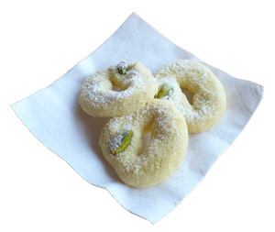

Ingredients
- 1 cup all-purpose flour
- 1 cup semolina flour
- 1 cup powdered sugar, plus more for dusting
- 1 cup clarified butter (ghee), softened
- 2 teaspoons orange flower water
- 1/4 teaspoon ground cardamom
- 1/4 cup (approximately) shelled pistachios
- 1/4 teaspoon fine-grained salt

Preparation Instructions
Preheat oven to 150 degrees celsius
Mix together the butter, sugar, and orange flower water until light and creamy. Sift together flours, salt and cardamom and stir into butter mixture until well combined. Chill dough for 30 minutes.
Form dough into grape-sized balls, then shape balls into wreaths, diamonds, "s" shapes, etc. (or leave round). Place a pistachio on each cookie.
Arrange cookies 1 inch apart on ungreased baking sheets. Bake 18-20 minutes, until cookies are dry to the touch and just starting to change color. Transfer cookies to a rack and immediately dust heavily with powdered sugar.
Makes about 3 dozen cookies.

