Mini croque monsieur

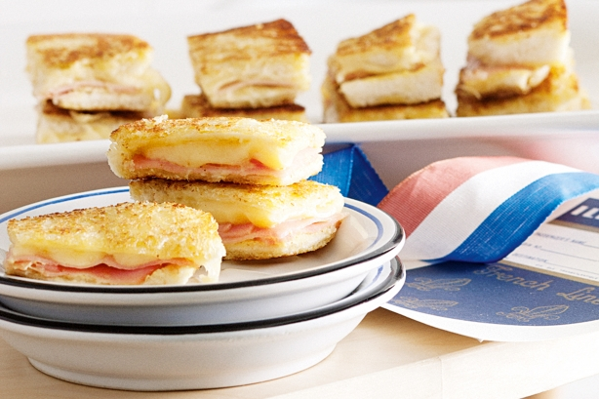
Ingredients:
- 1.5 loaves white bread, crusts removed
- butter, softened (enough to butter all the bread)
- Dijon mustard (enough to spread onto half the bread)
- 195g gruyere cheese, very thinly sliced
- 200g sliced leg ham – or enough for one piece on each sandwich

- Method
- Step 1
Lay all slices of bread on a chopping board and spread one side of each bread slice with butter. Place, buttered side down on the chopping board. Spread half the slices with mustard, then top with half the gruyere. Top with sliced ham. Season with salt and pepper. Top with remaining gruyere followed by bread slices, buttered-side up.
- Step 2
Using the grill plates on the stove on low heat - add half the sandwiches. Cook for 2 minutes each side (a spatula or egg lift is ideal for turning) or until golden and cheese has melted. Transfer to a baking tray and keep warm in a low oven. Repeat with remaining sandwiches. Cut each sandwich into three fingers and serve.
.

