Mixed Leaf Salad with radish and salad seeds
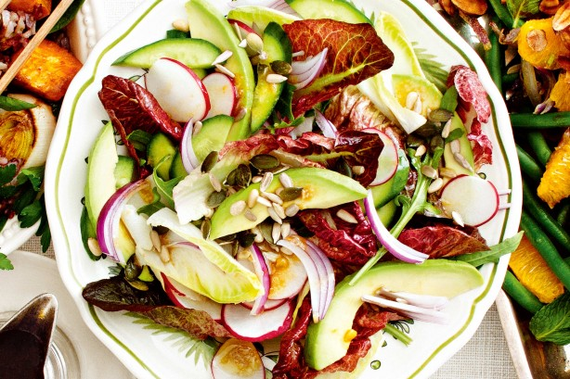
Lettuce  Rocket Leaves  Radishes  1 Cucumber  4 avocados  1 red onion  ¼ cup pumpkin seeds  ¼ cup sunflower seeds | Dressing:  80mls lemon juice  4cm piece ginger  4 tablespoons honey  2 tablespoons Dijon mustard  1.5 tablespoons soy sauce  ½ cup olive oil

Method: Salad
- Wash rocket and lettuce. Drain well and tear leaves into bite-sized pieces.
- Halve cucumber lengthways and thinly slice.
- Trim top and bottom of radishes and slice thinly.
- Cut avocado in half, remove stone and remove from shell. Slice thinly.
- Peel red onion, halve and thinly slice.
- Toast pumpkin and sesame seeds in a frying pan, stirring occasionally until golden brown.
- Place salad leaves on a large serving platter.
- Top with radish, cucumber, avocado and red onion.
- Drizzle with dressing and sprinkle with toasted seeds

Method: Dressing
- Juice lemons until you have the amount needed.
- Peel and finely grate ginger.
- Measure the remaining dressing ingredients and place in a screw-top jar. Add salt and pepper. Shake well.

