Niçoise Salad
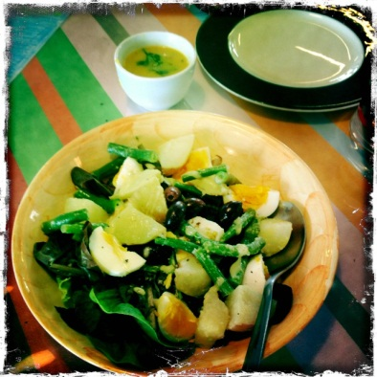
Serves: approximately 25 tastes
Equipment:  - Scales  - Chopping boards & knives  - Saucepans – med, small  - Colander  - Small jar & lid  - Measuring spoons: tablespoon, teaspoon  - Serving plates | Ingredients:  - 750g new (baby) potatoes  - 250g green beans  - 10 large eggs at room temperature  - A small handful baby lettuce leaves (if available)  - A handful small black olives (pitted)  - About 12 basil leaves  - Flaked salt and black pepper  For the dressing:  - 1 small garlic clove  - 120mls olive oil  - 2 tablespoon cider vinegar  - 2 teaspoon Dijon mustard  - A pinch of sugar
What to do:
- Wash the beans and potatoes – do not peel them! Tail the beans & chop into 3cm lengths.
- You can cook small new potatoes whole, but cut any larger ones in half or smaller, so they’re all roughly the same size. Cover with cold water in the medium saucepan, add salt and bring to the boil. Reduce the heat and simmer for 8-12 minutes until tender, adding the beans for the last 4 minutes. Drain, tip into a bowl and leave to cool.
- To cook the eggs, bring a small saucepan of water to the boil. Add the eggs, return to a simmer, then cook for 7 minutes. Lightly crack the shells and run the eggs under cold water for a minute or two to stop the cooking, then leave to cool. Peel and quarter the eggs.
- To make the dressing, put all the ingredients into a screw-topped jar, seasoning with salt and pepper, and shake until emulsified.
- Halve, quarter or thickly slice the cooked potatoes. Put them back with the beans, add some of the dressing and toss gently together.
- Wash the lettuce & basil leaves in several changes of water. Drain and dry well on paper towel and then gently toss in a bowl with a little of the dressing.
- Arrange the lettuce, potatoes, and beans on your serving plates and distribute the olives and eggs over the salad. Scatter with torn basil leaves, trickle over the remaining dressing and grind over some pepper. Serve straight away.

