Olive tapenade:
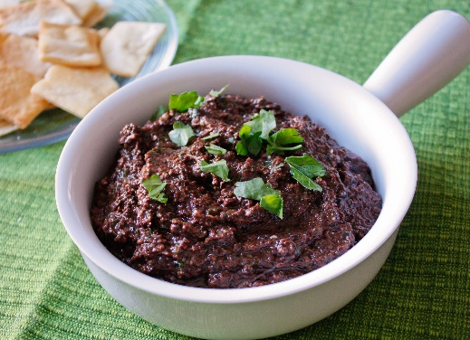
- 2 cup black olives, pitted and chopped
- 1 cup fresh basil leaves
- 4 teaspoons capers
- 2 clove garlic, crushed
- 1/2 cup olive oil
- juice from 2 small lemon or 1 large lemon
- sea salt to taste
- fresh cracked black pepper to taste

Method:
- Remove pits from olives and chop finely.
- Wash and finely chop basil leaves
- Finely chop capers
- Peel garlic and crush into a small bowl.
- Cut lemons in half and juice.
- Mix all prepared ingredients together and add salt and pepper to taste.

