Egg-free pancakes
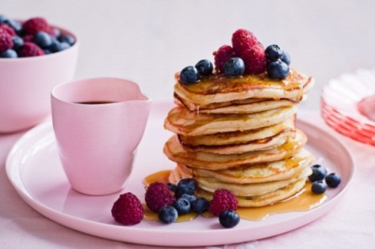

- Ingredients
4 cup self-raising flour
1 cup caster sugar
2 teaspoon bicarbonate of soda
4 cups milk
80g butter, melted
8 teaspoons white vinegar
4 teaspoon vanilla extract
Cooking spray, to grease

- Method
Step 1
Combine the flour, sugar and bicarbonate of soda in a medium bowl. Make a well in the centre. Pour the milk, butter, vinegar and vanilla into the well and use a balloon whisk to stir until smooth.

Step 2
Heat a medium non-stick frying pan over medium heat. Lightly spray with cooking spray to grease. Pour a ¼-cupful of batter into the pan. Cook for 1-2 minutes or until bubbles rise to the surface and the base is golden brown. Use a spatula to turn and cook for a further 1-2 minutes or until golden brown and cooked through. Transfer to a plate and loosely cover with foil to keep warm. Repeat with remaining batter to make more pancakes.
Step 3
Place the pancakes on serving plates. Top with lemon curd and serve immediately.

