Pasta with salami and olives
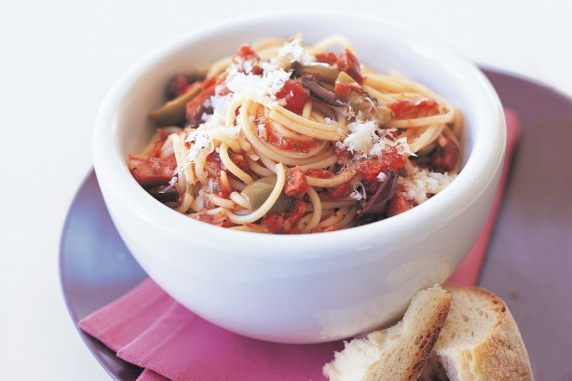
- 1/2 cup (60ml) olive oil
- 300g salami, cut into thin strips
- 3 cloves garlic, crushed
- 1/2 teaspoon chilli flakes
- 1 cup wine ( non-alcoholic or alcoholic)
- 2 tablespoon chopped fresh rosemary leaves
- 2 cup chopped fresh tomatoes
- 1kg spaghetti
- 400g black olives, pitted, roughly chopped
- 200g Grated parmesan, to serve

Method:
- Boil water for pasta. Add salt to water.
- Cut salami into thin strips. Remove core from tomatoes and dice into medium size pieces.
- Peel and crush garlic cloves. Grate parmesan cheese.
- Wash rosemary and remove leaves from stems. Finely chop the leaves.
- Remove pips from olives and roughly chop.
- Heat the oil in a large frypan over medium heat. Prepare any other ingredients from the garden to use in pasta sauce.
- Add the salami, garlic and chilli and cook, stirring occasionally, until the salami begins to crisp.
- Add the wine and rosemary and cook until the liquid has reduced by half, then add the tomatoes and cook for a further 5 minutes until thickened slightly.
- While the sauce is cooking, cook pasta in boiling salted water until al dente or according to packet instructions, then drain.
- Stir olives into the sauce and season to taste (this will vary, as the olives can sometimes be salty).
- Toss sauce with the pasta and serve with grated parmesan on top.

