Rhubarb muffins with rosewater syrup

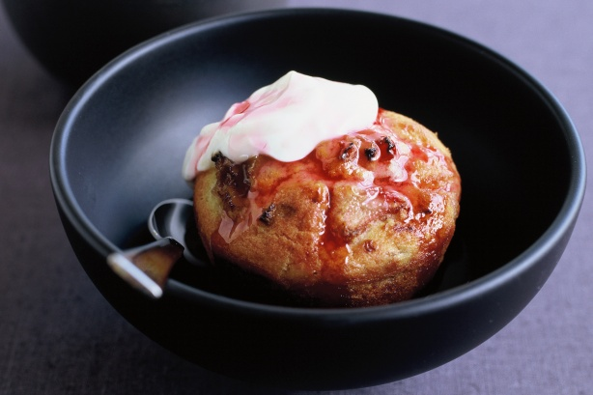
- 500g caster sugar
- 2 cup finely chopped rhubarb stems
- 4 teaspoons rosewater
- 440g plain flour
- 4 teaspoons baking powder
- 370ml buttermilk
- 2 egg
- 370ml vegetable oil

- Place 250g sugar and 1½ cup water in a saucepan over low heat, stirring until the sugar dissolves. Increase heat to medium and simmer for 5 minutes.
- Add rhubarb and 2 teaspoons of the rosewater and cook for 1 minute further or until rhubarb just starts to soften.
- Remove from heat and allow to cool. Drain, reserving the syrup.
- Preheat oven to 180°C. Grease two 12-hole muffin pans with cooking spray
- Sift the flour and baking powder into a large bowl and stir in remaining 250g sugar. Whisk together the buttermilk, egg and oil.
- Make a well in the centre of the dry ingredients, then add the liquid and stir until just combined.
- Stir in the rhubarb and remaining rosewater,
- Spoon mixture into muffin pan and bake for 25 minutes.
- Meanwhile, return the reserved syrup to the stove and boil for 5 minutes until reduced and syrupy.
- To serve, spoon the rosewater syrup over the warm muffins

