Rocket & Basil Pesto – To spread on pizza for Pizza of the Imagination in place of tomato pizza sauce
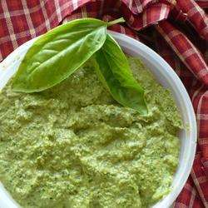

Ingredients
- 1 1/2 cups rocket leaves
- 1 1/2 cups fresh basil leaves
- 2/3 cup sunflower seeds
- 4 cloves garlic
- 185g pitted black olives
- 185ml extra virgin olive oil
- 1/2 lime, juiced
- 1 teaspoon red wine vinegar
- 1/8 teaspoon ground cumin
- 1 pinch ground cayenne pepper
- salt and pepper to taste

Directions
- Wash rocket and basil. Remove leaves from stems. Discard stems.
- Toast sunflower seeds in a medium sized frying pan, stirring frequently with a wooden spoon over low heat until seeds are lightly golden brown.
- Peel garlic and crush using garlic crusher.
- Chop pitted black olives. Juice the half lime.
- Place the rocket, basil, sunflower seeds, crushed garlic and olives in the food processor and chop to a coarse paste.
- Mix in olive oil, lime juice, vinegar, cumin, cayenne pepper, salt and pepper.
- Process until well blended and smooth. Spoon pesto out of food processor into a medium sized mixing bowl and give it to the group making the pizza.

