Spaghetti Carbonara with Kale
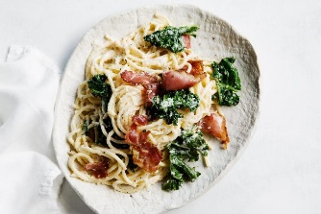

INGREDIENTS
- 750g spaghetti 300g bacon pieces
- 2 tablespoons extra virgin olive oil 4 garlic cloves, finely chopped
- 200g kale leaves, torn de-stemmed 2 cups Greek-style yoghurt
- 1 ½ cups finely grated parmesan 4 eggs
- 4 egg yolks Finely grated parmesan, extra, to serve

METHOD
- Step 1
Fry the bacon pieces in a non-stick frying pan. Peel and chop garlic.
- Step 2
Wash kale, remove stems and shred leaves into thin strips. Heat the oil in the frying pan over medium heat. Add garlic and cook for 1 minute or until aromatic. Add the kale and cook, stirring for 3 minutes or until slightly wilted. Grate parmesan cheese. Cook the pasta in a large saucepan of salted boiling water until al dente. Drain. Return to the pan
- Step 3
Separate 4 of the eggs. Keep the yolks. Combine the yoghurt, parmesan, whole eggs and the egg yolks in a bowl. Season well with black pepper.
- Step 4
Add the egg mixture and kale mixture to the hot pasta. Toss to combine. Serve topped with the bacon sprinkled over the top and extra parmesan.

