Stewed Fruit Crumble
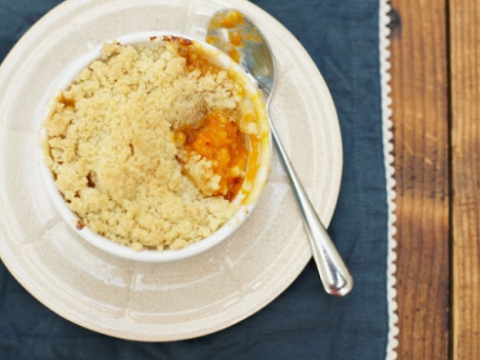

Ingredients
- • 1kg seasonal fruit such as rhubarb, plums, apricots, strawberries or pears
- • if using rhubarb: a 2.5cm piece of fresh ginger
- • caster sugar, to taste
- • 400g plain flour
- • 250g butter
- • 150g sugar, preferably light brown or golden caster sugar
- • a pinch of sea salt

To make your stewed fruit

- 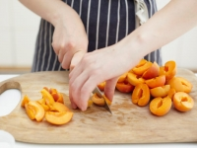
• Chop up all the fruit, discarding any stones
• Place the fruit in a pan
• If using rhubarb, peel the ginger and finely grate it into the pan

To make your stewed fruit

- 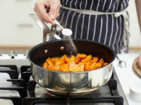
• Add the sugar – I usually add 3 heaped teaspoons to rhubarb and 2 heaped teaspoons to any other fruit, but just taste as you go along and add more if you think it needs it (please be careful when tasting as it gets really hot)
• Add 2 tablespoons of water and cook on a medium heat with the lid on
• Once the fruit has softened, remove the lid and let the liquid reduce – you want to end up with a fairly thick consistency

To make your fruit crumble
• Preheat the oven to 180ºC/350ºF/gas 4
• Place stewed fruit into ovenproof baking dish
• Make a crumble mixture by rubbing the plain flour with the butter, sugar and a pinch of sea salt

To make your fruit crumble
• Once the mixture resembles breadcrumbs, sprinkle it evenly over the stewed fruit
• Bake in the hot oven for 15 to 20 minutes, or until the top is crisp and the fruit is bubbling up at the sides
• Serve with ice cream

