Tabbouleh
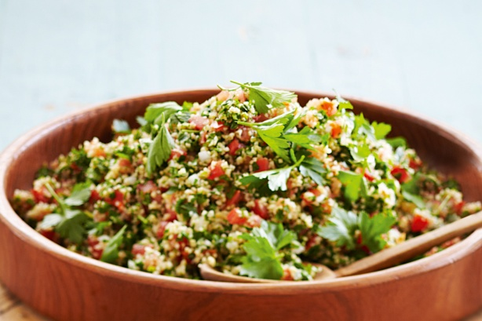
- 2 cups burghul (cracked wheat), rinsed
- 3 bunches fresh flat-leaf parsley leaves, chopped (see tip)
- 2 bunches fresh mint leaves, chopped (see tip)
- 8 ripe tomatoes, finely chopped
- 3 red onion, finely chopped
- 200mls olive oil, to taste
- Juice of 5-8 lemons, add to taste
- Salt and pepper, to taste

- Place burghul in a bowl. Cover with boiling water. Stand for 20 minutes or until softened. Drain. Rinse under cold water. Drain, pressing out water with a metal spoon.

- Place burghul, parsley, mint, tomato and onion in a bowl. Stir to combine.

- Place oil and lemon juice in a mixing bowl and whisk to combine. Drizzle over tabbouleh. Season with salt and pepper. Toss to combine. Serve.

