Thai Sticky Rice Balls
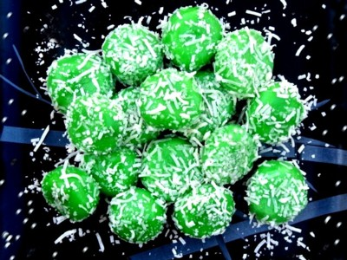
2 cups glutinous rice flour
Approximately 1 can light coconut milk
Approximately 2 cups brown sugar
1 cup shredded coconut
1 teaspoon pandan essence
Salt

Method:
- Place rice flour into mixing bowl. Add pinch salt. Add ½ can coconut milk to begin with
- Stir coconut milk into flour to form a dough. You may need more coconut milk or more rice flour to form a dough
- The dough should be similar texture to play dough. If it doesn’t stick together – it is too dry and needs more coconut milk.
- Add pandan essence to colour the dough and to give a hint of pandan leaf sweetness
- Stir essence in well to evenly colour the dough
- Take small pieces of dough and roll into balls
- Make an indent in the ball with your thumb. Place ½ tablespoon of brown sugar in the rice ball. Pat sugar down with your finger
- Pinch sides together to cover the sugar and close the ball
- Roll ball in your palm to make it round again
- Place on cutting board dusted with rice flour. Continue making and filling balls until all dough is used up
- Bring pot of water to boil. When boiling, drop rice balls into pot (get the adult to do this part). Turn heat down to just keep water bubbling.
- Once rice balls rise to surface, cook for further 2 mins (4 minutes in total)
- Prepare baking trays with baking paper, spray lightly with oil.
- Remove balls from water onto baking trays
- Place shredded coconut on plate. Roll rice balls in coconut to coat.
- Place finished balls on plate. Eat while still warm or at room temperature. Store leftover balls in airtight container. Do not refrigerate. Eat within 24 hours of making or they will go hard.
- Enjoy!

