Tomato Soup with Rocket Pesto
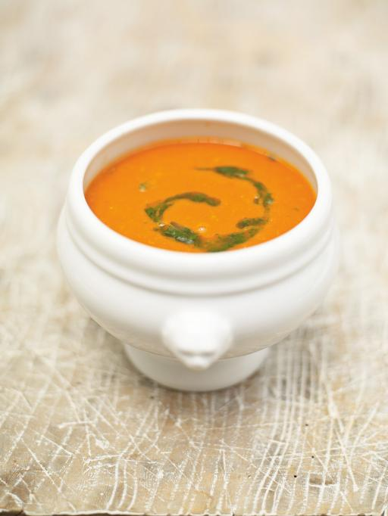

3 carrots
3 sticks celery
2 onions
3 cloves garlic
Olive Oil
2 teaspoons vegetable stock powder
2 x 400g tins tomato
6 large tomatoes
1 bunch parsley

Rocket Pesto

200g washed rocket leaves
3 cloves garlic
3 tablespoons lemon juice
½ cup parmesan cheese
1 ½ teaspoon salt
1 tsp black pepper
½ cup olive oil

Peel and roughly slice the carrots. Slice the celery.
Peel and roughly chop the onions. Peel and slice the garlic.
Put a large pan on a medium heat and add a couple of lugs of olive oil.
Add all your chopped and sliced ingredients and mix together with a wooden spoon.
Cook for around 10 to 15 minutes until the carrots have softened and the onion is lightly golden.
Bring to boil 1.5 litres of water in a saucepan
Put the stock powder into the boiling water and stir until the stock powder is dissolved.
Add vegetable stock to the pan with your tinned and fresh whole tomatoes, including the green stalks that may still be attached to some of them (these give an amazing flavour!)
Give it a good stir and bring to the boil. Reduce the heat and simmer for 10 minutes with the lid on. Meanwhile, chop the parsley and make the rocket pesto
To make the pesto:
Place rocket, garlic, lemon juice, parmesan cheese, salt and pepper in food processor or blender.
Turn on machine and blend for 30 seconds.
Slowly pour in olive oil while machine is running.
Process until smooth.
To serve your soup:
Remove the pan from the heat. Season with salt and pepper and add the parsley leaves.
Using a hand blender or, pulse the soup until smooth. Season again before dividing between your serving bowls.
Place a spoon of rocket pesto on top of each bowl of soup

