Tomato, Herb & Cheese Pastry Twists
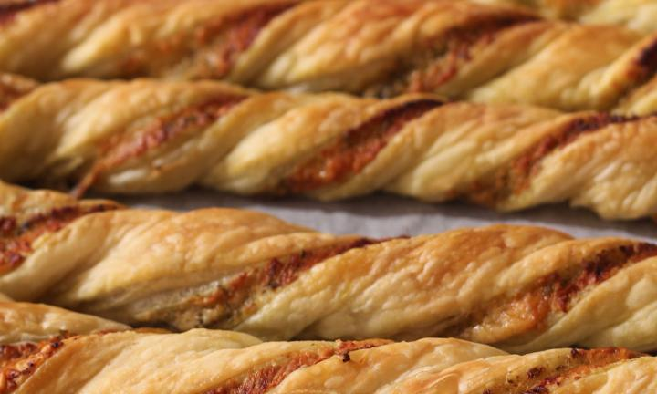
8 slices puff pastry, thawed
Tomato Paste
Parsley
Oregano
1 cup grated parmesan cheese

- Preheat oven to 180ºC (160°C fan-forced).
- Line four baking trays with baking paper and set aside.
- Remove leaves from the herbs. Discard the stems. Finely chop parsley and oregano.
- Place one sheet of puff pastry on bench.
- Using a dinner knife, spread pastry lightly with tomato paste.
- Sprinkle with parmesan cheese. Sprinkle with chopped herbs.
- Place second sheet over the first and roll over the top with a rolling pin.
- Repeat the process above with the other pastry sheets.
- Cut the pastry into 2cm wide ribbons.
- Place on baking tray and twist. Spray with cooking spray or brush with lightly beaten egg.
- Bake for 10-15 mins or until golden.

