Pizza with Warrigal Greens, Garlic & Herbs

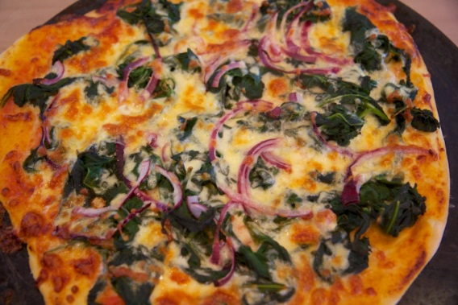

Topping
2 x pizza bases
300g warrigal greens, leaves only
12 leaves of green leafy vegetables (silverbeet, kale, etc.) finely chopped
½ cup oil
2 clove garlic, crushed
1 / 2 red onion
300g mozzarella
2 teaspoon chopped rosemary
2 teaspoon chopped oregano
2 tablespoon chopped parsley

Method
- Spray pizza trays with cooking oil. Roll pizza dough to fit round pizza trays. Place rolled out dough onto greased trays.
- Boil small saucepan of salted water for warrigal greens. Wash warrigal greens and remove leaves from stems.
- Blanch the warrigal greens in boiling water for 3-4 minutes.
- Peel and crush garlic. Peel and thinly slice red onion.
- Drain warrigal greens and run under cold water. Drain again and squeeze out all excess water. Chop roughly.
- Wash assorted green leafy vegetables, remove leaves from the stalks and finely chop.
- Grate mozzarella cheese. Peel and slice red onion thinly.
- Wash herbs, remove leaves from stalks and finely chop herbs. Keep herbs aside for topping the pizza.
- Heat oil in a fry pan on medium heat, add crushed garlic and cook for 30 seconds. Add chopped warrigal greens and assorted leaves and fry until wilted.
- Scatter pan-fried greens over pizza base. Top pizzas with red onion.
- Top with mozzarella and herbs.
- Add a little salt and pepper and then drizzle with a little bit more olive oil.
- Bake for 15-20 minutes or until crisp and golden.

Note: Fresh Spinach/Baby Spinach can be used instead of warrigal greens and does not need cooking before pan-frying with the other green vegetables.

