Jerusalem Artichoke Pizza
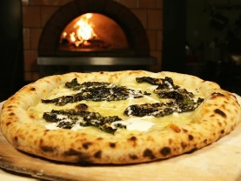

Ingredients
- 4 Jerusalem artichoke | - 2 tablespoon roughly chopped fresh rosemary
- 150g Grana Padano/Parmigiano-Reggiano | - 6 whole leaves kale, stems trimmed
- Olive oil, for drizzling | - Salt
- 2 pizza bases (made by other group) | - ¾ cup shredded tasty cheese
- ¾ cup shredded mozzarella | - Crème fraiche or thinned down sour cream, for drizzling

Directions
- Preheat oven to 220°C.
- Wash and scrub Jerusalem artichokes to remove the dirt.
- Slice the Jerusalem artichoke as thinly as possible with either the slicing attachment on the kitchen aid mixer or using a mandolin into a bowl.
- Grate the grana Padano cheese (parmesan)
- Wash rosemary, remove leaves from stalk and finely chop rosemary.
- Wash the kale, remove stems and roughly chop.
- Toss together the rosemary, Grana Padano, kale, a generous dash of olive oil and a generous pinch of salt, coating everything evenly and massaging the kale to soften it up.
- Grate/shred the mozzarella and the tasty cheese into two separate bowls. Lay down the mozzarella, then an even layer of the sliced artichokes, followed by the kale and rosemary mixture.
- Top the pizza with the tasty cheese. Put the pizza in the oven.
- Thin out the sour cream/crème fraiche with a little water to make it slightly runny to drizzle on pizza.
- Cook until the pizza is evenly browned, 10-15 minutes.
- Take pizza off the trays onto two chopping boards.
- Cut each pizza into 16 even pieces and drizzle with crème fraiche/sour cream.

