Grade 3-4
Clubs.
Our lunch time club program is now in full swing, with a selection of 20 different activities students can choose to participate in, running throughout the week. Clubs include chess, art, Lego, a “Number Crunchers” club and a Eukele ensemble, just to mention a few.
Our Junior School Council representatives have busily been collecting feedback forms from across the 3-4 classes (indeed, from across most of the school), to help inform how we can make this program even more effective.

Maths
In recent weeks we have explored, examined and wracked our brains around several key mathematical concepts.
We have made many different arrays, using counters, paper strips of printed dots as well as hand drawing them into our books. We have also answered quiz questions and solved problems centered around arrays. This work with arrays is very helpful in empowering students to visualize numbers in terms of groups, which leads to a solid understanding of number patterns and multiplication.
We have also measured the height, width, weight and area of many objects, from school diaries, to school desks to the students themselves. We have undertaken hands-on activities to see just how heavy several metric weights really are.
Plastic, paper and wooden three-dimensional shapes have been a major part of the 3-4 classrooms recently. Our students can now tell you all about nets of 3D shapes, what a vertex, edge and face is and the difference between a prism and a pyramid. They have also looked at ‘nets’ like the ones below, and found which will make a cube, and which will not.
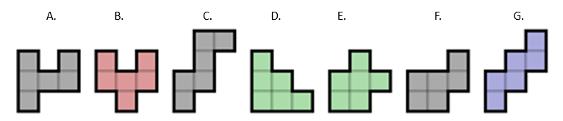

Reading
We have continued our daily Reading Workshops, focusing on comprehension skills such as ‘questioning the text’ and ‘visualizing’. Students have been recording their thought and reflections in their Reading Workshop books. Recently, we have begun ‘Reading Conferences’, where teachers and students discuss and agree upon personal reading goals and relevant activities to help students achieve them.

Writing
We have wrapped up our focus on descriptive writing and have jumped head first into narratives. Students have carefully crafted their plans and drafts, improving the beginning, middle and end of each narrative with generous helpings of self-editing and self-revision. Ghost stories, adventures, heroic escapes and dramatic friendship implosions are just some of the narrative experiences the grade 3-4 students have been brewing. Look out for these in the coming weeks on our writing wall outside the staffroom.

