­

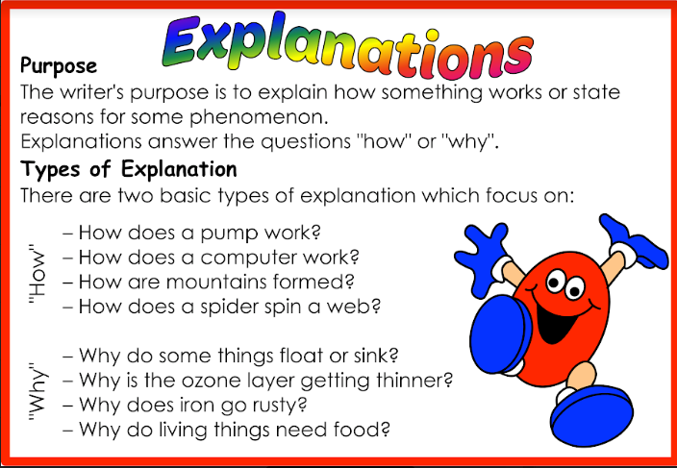

News from the 1/2s

**Term 2 - Weeks 5 and 6!**

**In Reading:**

Over week 5 and 6 we have been looking at ‘EXPLANATION’ texts. We have identified that an explanation describes a sequence of natural or non-natural processes or phenomena. An explanation text focuses on ‘HOW’ and ‘WHY’.

Did you know that it takes a young frog about 2-4 years to become an adult? We read a text ‘How Frogs Become Frogs’. The text explained the stages of a frog’s development from an egg, tadpole then to a frog. Then the lifecycle begins again.

We have also looked at technical vocabulary relevant to an explanation text and identified this in ‘How Bees Make Honey’...honeycomb, nectar, pollen, Manuka.

**In Writing:**

How exciting! The past two weeks the students have been editing a PERSUASIVE writing piece for publishing. Students have demonstrated their editing skills by proof reading, checking spelling, punctuation and making sure that their arguments are convincing. We have now published our favourite persuasive writing piece, which will either be on display in our classrooms or on the ‘Writing Wall’.

The highlight for our students in writing was Week 6. The teachers have been preparing the students over the term by sharing our personal Writer’s Notebook. Students were introduced to their ‘Writer’s Notebook’ and were able to design their front page and create their personal profile page. The smiles on their faces showed their enthusiasm

**In Mathematics:**

In Week 5 we continued to look at both ANALOGUE and DIGITAL TIME. We have continued to discuss the duration of how long things take to do by identifying seconds, minutes and hours. We have made real life connections, linking this in with our daily school routines.

This past week, our new unit has been SUBTRACTION. We have been learning to solve subtraction problems and record their number sentences. Materials such as MAB, abacus, 100s number boards and number lines have enabled students to show taking away of a number to find their answer.

**‘Please explain…**

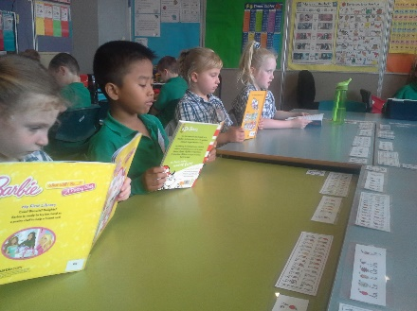

**‘HOW’**

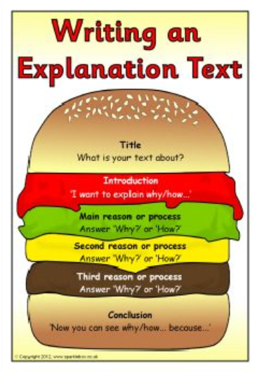

**‘WHY’**

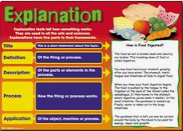

**EDUCATION WEEK:**

What a wonderful week our students had! It was a very busy week as we played games that were played in the ‘Olden Days’.

Our Education Open afternoon provided students with the opportunity to explore a range of careers. The students were also able dress up in their desired future career. Thank you for your support in this very busy and special week.

**NOTE ABOUT… Learning at Home:**

Please continue supporting your child in their reading. It really benefits them in developing confidence in reading. Likewise, supporting your child with their learning of the **Magic 100 /200** Words and **Oxford** Spelling Words is time well spent!.

Don’t forget the students can also practise their skills and learning at home using **MATIFIC** and **READING EGGS /READING EGGSPRESS.**

**COOKING: What’s on the menu?**

**Week 7**– Lemonade Scones.

If you can assist in our cooking program, not only would we appreciate it, but your child would love your support. ☺

**Upcoming Dates:**

**7th June** – Colour Run

Year 2 Weekly Homework due

**10th June** – Queen Birthday Holiday

**17th June** – Toys Over Time ‘Incursion’

**18th June** – NAIDOC WEEK Year F – 2 Music/Dancing

**19th June** – Year 5/6 Market Day – All students have

opportunity to make purchases.