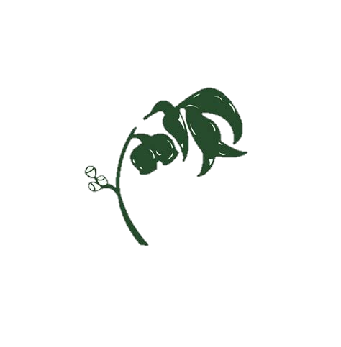

Coming Up

Colour Run – 7th June (FRIDAY)

Public Holiday -

3/4 Hoop Time – 14th June

Grade 3/4  
NEWS

Term 2, Week 6, 2019

Maths - Symmetry

This week in Mathematics we have been looking at lines of symmetry in the world around us. The students are finding it fascinating how many objects around them have multiple lines of symmetry, such as buildings, animals and artwork. The students got the opportunity to draw a symmetrical illustrations to cement the understanding of symmetry.

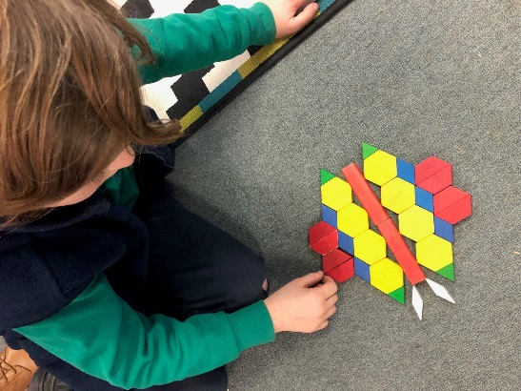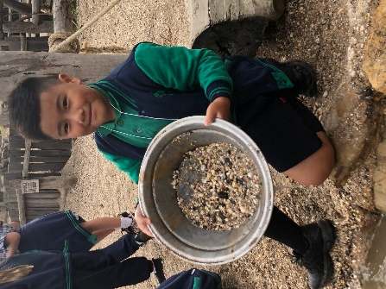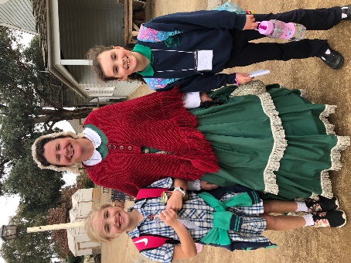

Graphic Novels

We are excited to see lots of children enjoying

Graphic Novels at school!

A graphic novel uses images—often in a comic strip style—to tell a story. With pictures or illustrations and *a lot less* text, graphic novels help children practise reading. They also can help them build positive associations with books.

With graphic novels, children still have to do the mental work of understanding the story line. This includes the plot, narrative, character development, problem and resolution. The skills children develop with graphic novels can improve their ability to get through other kinds of books. After finishing that graphic novel, and then that graphic *series*, your child may just pick up a long-ignored book.

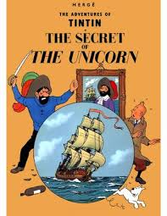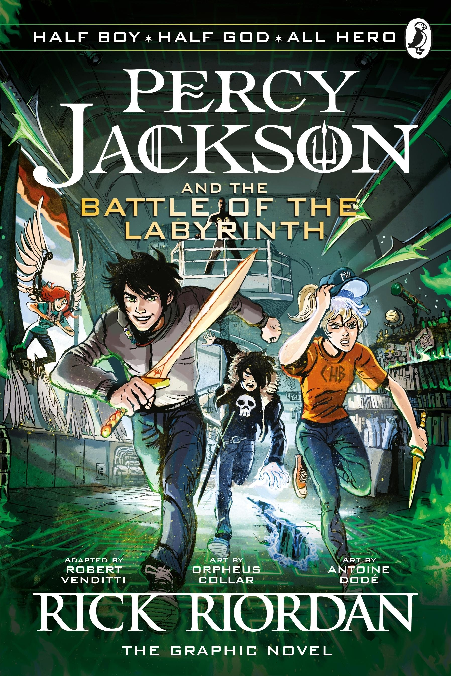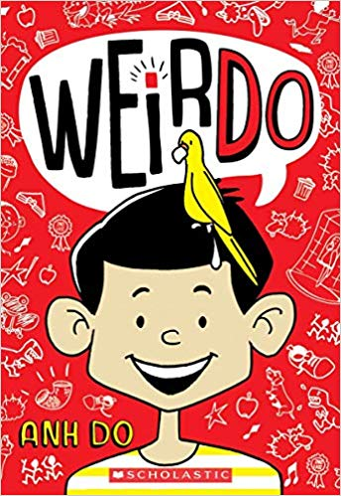

Some other suggestions…

**Bad Guys** by Aaron Blabey

**Frooties** by Rogers, Lefers & Petrovic

**Tom Gates** by Liz Pichon

**WeirDo** by Any Do

**Dork Diaries** by Rachel Renee Russell

**The 13-Storey Treehouse Series** by Andy Griffiths & Terry Denton

**The Babysitters Club** – Ann M Martin

Smile - [Raina Telgemeier](https://www.booktopia.com.au/search.ep?author=Raina%20Telgemeier)

Captain Underpants by Dav Pilkey

Geronimo Stilton - by Geronimo Stilton

Thea Stilton by Thea Stilton

Reading

This week in Reading, the students have explored the author's perspective in Non-Fiction texts. They have worked to differentiate between what is a fact and what is the author's opinion on the subject.

At home, you can support your child by reading Non-Fiction texts with them. First, ask what type of non-fiction text they are reading and what the topic is. Then, discuss what the author's opinion on the topic is and what your child thinks about the same topic.

Writing - Sovereign Hill

My favourite part of the day was seeing the Welcome Nugget in the bank. It would be very heavy and expensive. – Matilda

I loved Sovereign Hill and I think we should stay longer. – Tom

Second last of all we went bowling. We set up our own pins. At the bowling centre there were nine pins and instead of a tower it’s a diamond. It is weird but it was lots of fun. - Batul