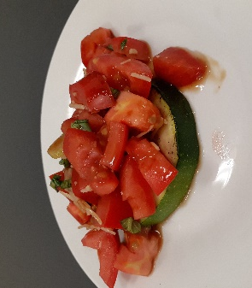
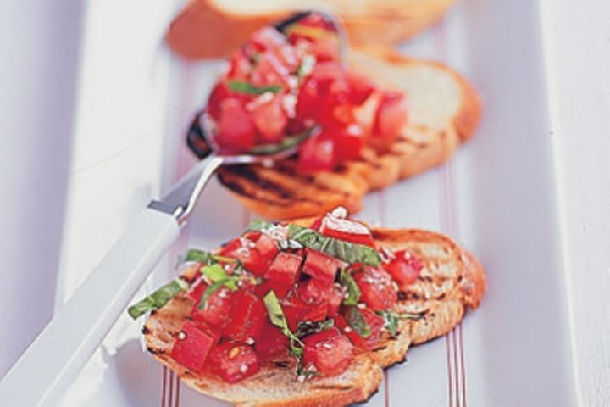
Bruschetta
Serves 6

Ingredients
-Sliced French bread stick OR zucchini cut into rounds 1cm thick.
-4 medium tomatoes, diced
-3 sprigs basil, finely chopped
-1 clove garlic
-pinch rock salt
-pinch pepper
-2 spring onions, finely sliced
-2 tsp balsamic glaze
-olive oil to brush over bread or zucchini
-1 Tbs finely grated parmesan cheese

Method
- Brush olive oil over bread or zucchini and grill until toasted / grilled.
- Lightly crush garlic clove and rub over bread / zucchini.
- Mix diced tomato, finely chopped basil, finely sliced spring onion, balsamic glaze, salt, pepper and parmesan cheese in a bowl. Allow to sit for 10 minutes for flavours to combine.
- Serve over bread or zucchini. Enjoy.

