Egg-free ANZAC Biscuit recipe
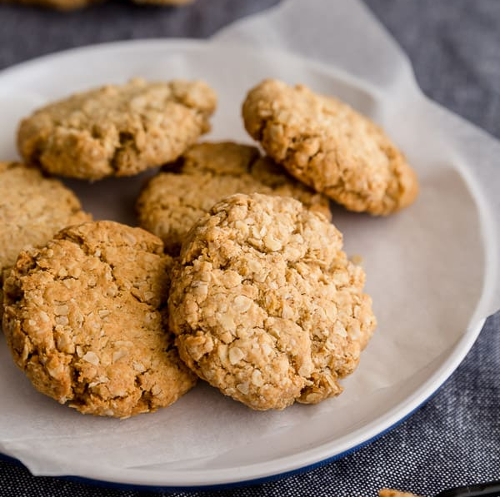
Makes 12

Ingredients:
-180g oats
-80g caster sugar
-150g self-raising flour
-150g melted butter
-1 ½ Tbs golden syrup
-2 Tbs coconut
-1 tsp cinnamon
-4 Tbs water

Method:
- Pre-heat oven to 180⁰C, line a baking tray with baking paper.
- Add dry ingredients to a mixing bowl and stir well to combine.
- Add wet ingredients and stir thoroughly to combine.
- Spoon out walnut sized portions into your hand and roll into balls. Place on baking tray and flat each slightly using hand or fork.
- Bake for 20 – 30 minutes or until lightly golden brown.

