Egg & Nori Rolls
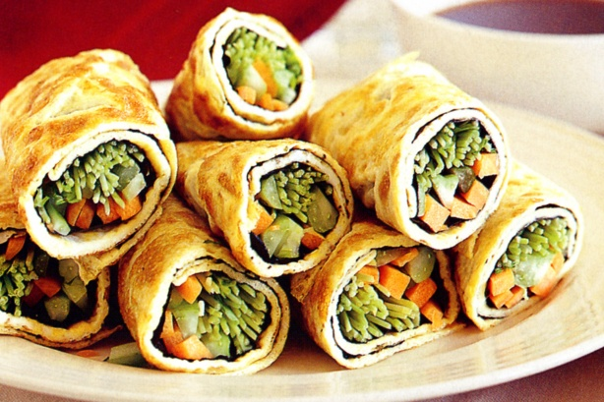
- 6 tablespoons soy sauce
- 1 teaspoon wasabi paste
- 250ml water
- 16 eggs, at room temperature
- Pinch of salt
- 40g (1 tablespoon) butter
- 8 sheets sushi nori (roasted seaweed)
- 2 carrot, peeled, cut into thick matchsticks
- 4 celery sticks, trimmed, cut into thick matchsticks
- 80g snow pea sprouts, stems trimmed
- 2 smoked chicken breast, finely shredded

- Whisk the soy sauce, wasabi and ½ cup water in a small bowl until well combined. Cover and set aside until serving.
- Crack the eggs into a large jug and add the remaining water. Add salt and use a fork to whisk until well combined.
- Heat 1 teaspoon of the butter in a 20cm non-stick frying pan over medium-high heat until foaming. Pour a quarter of egg mixture into pan and tilt pan until mixture covers base. As omelette begins to set, lift edge so uncooked egg runs underneath.
- Cook, uncovered, for 2 minutes or until omelette is set. Slide onto a large plate and cover loosely with foil to keep warm. Repeat in batches with remaining butter and egg mixture.
- Place the omelettes in a single layer on a clean surface. Top each with 1 nori sheet. Divide carrot, celery, snow pea sprouts and smoked chicken among nori sheets, placing down the centre.
- Roll the omelette up tightly. Trim edges and cut the rolls in half. Arrange on a serving plate and serve with the wasabi mixture.

