[](http://www.google.com.au/url?sa=i&rct=j&q=&esrc=s&source=images&cd=&cad=rja&uact=8&ved=0ahUKEwip16WW_d3MAhXFnpQKHSByCtAQjRwIBw&url=http://www.dogoilpress.com/FDS-396756.html&psig=AFQjCNFE8WffKP1r9rIyd-iMiHYRN3waSg&ust=1463466881776588)[](http://www.google.com.au/url?sa=i&rct=j&q=&esrc=s&source=images&cd=&cad=rja&uact=8&ved=0ahUKEwiz6KbQg97MAhVoJ6YKHQK_BHAQjRwIBw&url=http://www.tarameddaugh.com/blog/2015/9/3/reading-with-your-child-start-drama-early&bvm=bv.122129774,d.dGY&psig=AFQjCNFR_pdP4IrHnH-mDJIpVx_p75UDBw&ust=1463468619554548)[](http://www.google.com.au/url?sa=i&rct=j&q=&esrc=s&source=images&cd=&cad=rja&uact=8&ved=0ahUKEwj02disg97MAhVFtJQKHR67D_EQjRwIBw&url=http://www.mycutegraphics.com/graphics/school/supplies/lime-green-calculator.html&bvm=bv.122129774,d.dGY&psig=AFQjCNEavZJHBge9dm9mbQPAIyV7FfN68w&ust=1463468548912327)[](http://www.google.com.au/url?sa=i&rct=j&q=&esrc=s&source=images&cd=&cad=rja&uact=8&ved=0ahUKEwjm25iahN7MAhWIQpQKHbSKBlgQjRwIBw&url=http://4-designer.com/2014/07/Cartoon-chef-design-vector-material/&bvm=bv.122129774,d.dGY&psig=AFQjCNFkQnJgl52Ra0R51kCpT2bMlQ-q-g&ust=1463468726726551)[](http://www.google.com.au/url?sa=i&rct=j&q=&esrc=s&source=images&cd=&cad=rja&uact=8&ved=0ahUKEwixpfWA_t3MAhUGVZQKHYjiBjQQjRwIBw&url=http://www.clipartpanda.com/categories/school-newspaper-clipart&bvm=bv.122129774,d.dGY&psig=AFQjCNHept1E2zoD0Mep01i8ptYiFz9TUA&ust=1463467040400840)

SAKGP

Garden- This past week students were very preparing, maintaining and cleaning up the garden areas ready for Education Week. With autumn well and truly here, the leaves have been falling so raking them up has been lots of fun.

Kitchen

Last week the students made a Chickpea Salad, Pasta with Pesto, Pita Crisps and a Roasted Pumpkin Dip. We are very appreciative of all the parents who are coming to assist us with cooking. A big THANK YOU!

Photos

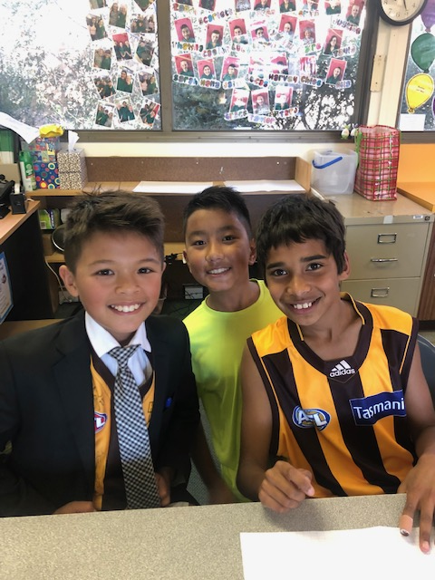 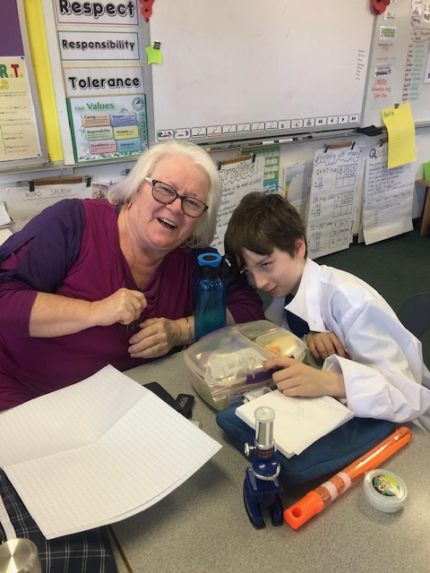 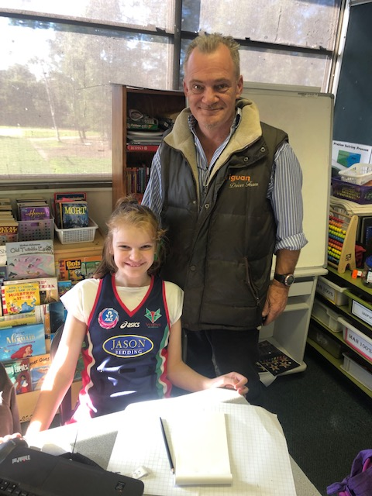 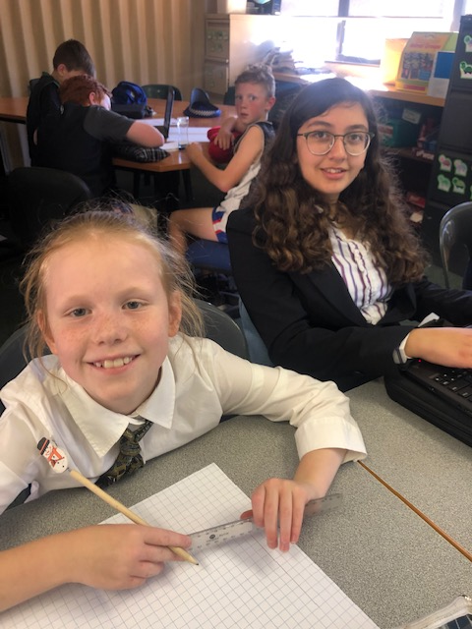

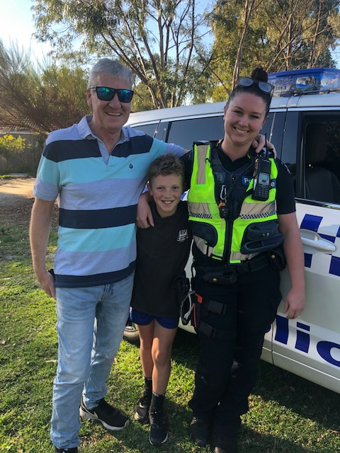 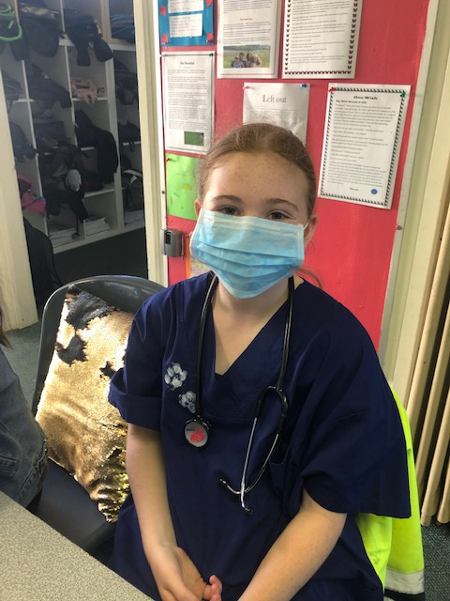 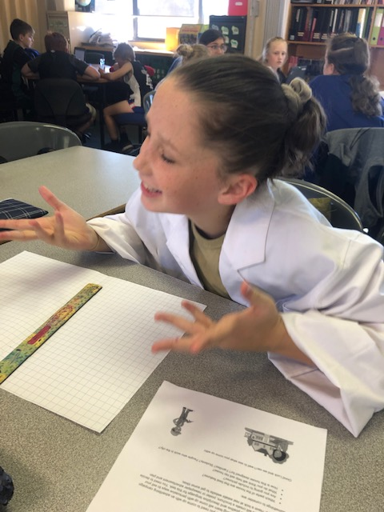 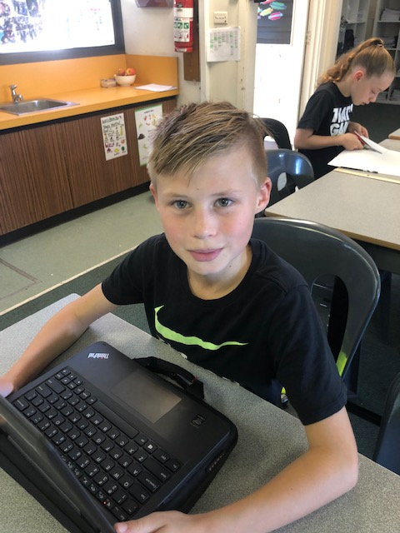 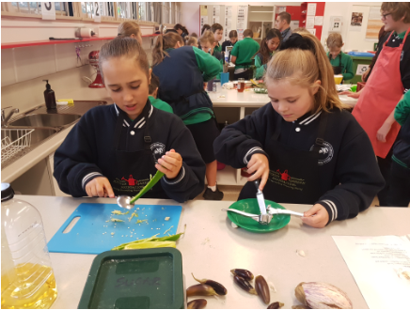 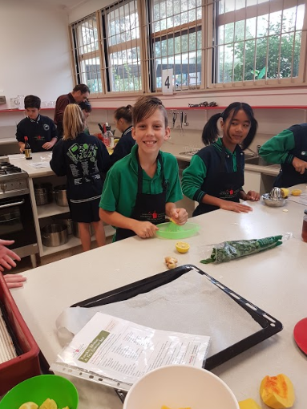 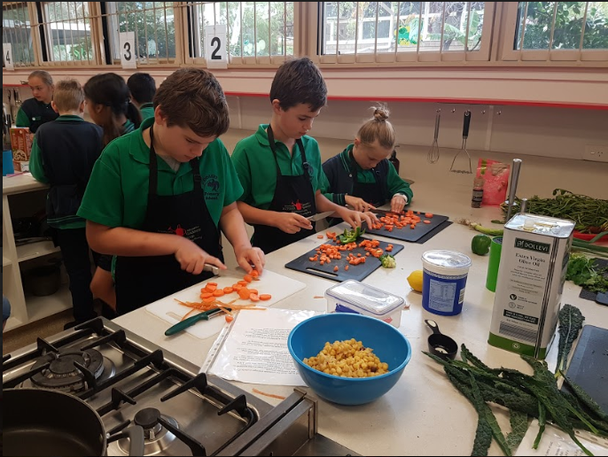

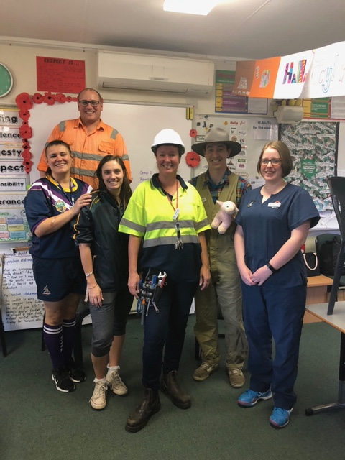

Maths

In Maths, students have been working on creating some spectacular designs with their tessellation patterns. They have learnt to include not only shapes that have no overlapping or gaps, but how to translate, reflect and transform them (flip, slide and turn). They have also been learning about probability and how to make a reasonable guess according to the data that is presented.

Integrated

The students in the 5/6 area have been busy learning about setting up a business. They have been working in groups, assigned a CEO to their own groups and been learning to work together as a team. All of this is in preparation for the exciting times ahead. Market Day for year 5/6 is fast approaching and with all groups having their stalls assigned, the excitement is growing. A very busy time ahead for our students. Watch out for all the advertising that will be appearing soon.

Friday Sport

The winter season of inter-school sport is continuing to take place every Friday afternoon. So far results have been varying, but all in all the students are enjoying their time.

Education Week  
On Thursday 23rd June the school was open for Education Week. Students and Staff dressed up in a CAREER that they potentially would like to become. It was a fun day with a parade in the morning. During the afternoon, family, friends and special visitors came along to enjoy the classroom activities and special afternoon tea. The 5/6’s worked on designing and advertising a house. – “How many people does it take to build a house?” Some amazing designs!!! In the evening students and family again came back to school for Open Night. A great turn out!

Literacy

In Reading, students have been focusing on making connections to the texts they are reading. Text to text, text to self and text to world connections have been taught by teachers. Students then transferred this learning focus onto their independent reading text.

In Writing, students have been focusing on persuasive pieces. They have been given topics to write about, and so far, have proven to be very persuasive with their language. These pieces of writing will be displayed on the Writing Wall by then end of Week 6. Keep an eye out!!

NAPLAN: A HUGE congratulations to the Year 5 students who worked extremely hard during this time, and to their Year 6 classmates who encouraged their peers along the way. Well done to all involved.

Coming Up:

**The Ridiculous Rhyme Show - Friday 31st May  
Colour Run – Wednesday 5th June  
Market Day – Wednesday 19th June  
Hooptime – Friday 21st June**

5/6s

NEWS

**FROM**

**THE**