Green Bean & Lemon Couscous
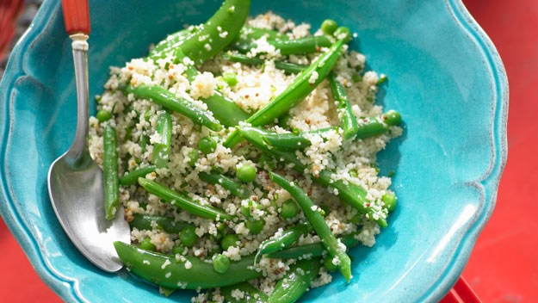

Ingredients:

2 teaspoons vegeta powder
3 cups couscous
400g green beans
200g cherry tomatoes
1 cup frozen peas
¾ cup chopped flat leaf parsley
1 fresh long red chilli
2 Teaspoons finely grated lemon zest
3 Tablespoons lemon juice
4 Tablespoons olive oil

Method:
- Combine vegeta powder with 3 cups boiling water in a heat proof jug
- 2. Place couscous in a large heatproof bowl. Stir in the stock mixture. Cover with plastic wrap and set aside for 5 minutes or until all the liquid is absorbed.
- 3. Using a fork carefully scrape at the couscous until it becomes fluffy and the grains are separate.
- 4. Wash and top and tail beans before chopping them into 2cm pieces. Cook beans and frozen peas in boiling salted water for 3 minutes or until tender. Drain and refresh under cold water.
- 5. De seed and finely chop the chilli. Zest the lemons and squeeze the juice from them.
- 6. Halve the cherry tomatoes. Chop the fresh parsley.
- 7. Add tomatoes, beans, chilli, parsley and lemon zest to couscous.
- 8. Whisk lemon juice and olive oil in a jug, season with salt and pepper.
- 9. Pour dressing over bean and couscous mixture; toss to combine.

