Kaffir Lime Aioli
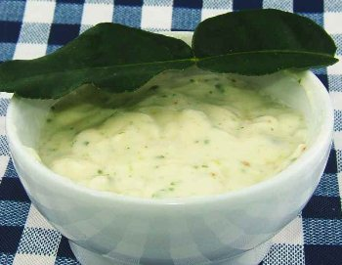
Equipment:
metric measuring cups | Egg separator
chopping board | cook’s knives
citrus juicer | clean tea towel
medium bowl and whisk | Grater/zester
Ingredients: | 3 garlic cloves, peeled
3 eggs | juice of ½ lemon
salt, to taste | 1½ cups light olive oil
1 kaffir lime, zested and juiced
1. Peel and crush garlic into the medium bowl.
2. Separate the egg yolks from the egg whites and add the yolks to the bowl with the garlic.
3. Juice the lemon half and add with a pinch of salt to the medium bowl.
4. Whisk the garlic, yolks and lemon juice together. While whisking, gradually add the olive oil in a constant thin stream. (Do not add the oil too quickly as the mixture can split.) It should become thick.
5. Finely grate zest of the kaffir lime and juice it after zesting. Gently mix zest and juice into aioli. Taste to check if it needs salt and pepper. Serve.

