Kenyan Potato Bhajias
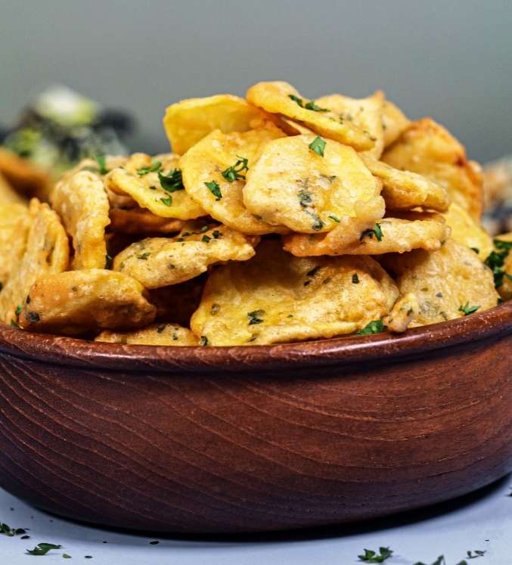
Serves 6

Ingredients:
-6 medium potatoes thinly sliced
-1 cup plain flour
-1 cup besan (chick pea) flour
-1 tsp garam masala
-1 tsp paprika
-1 tsp cumin
-2 tsp minced garlic
-2 tsp minced ginger
-2 tsp chopped coriander leaves / paste
-pinch salt
-approximately 1 cup water
-oil for deep-frying

Method:
- Combine flour, besan flour, garam masala, paprika, cumin and coriander in a large mixing bowl.
- While stirring, add water slowly until the mix resembles a thin pancake batter.
- Stir garlic and ginger into batter.
- Dip the slices of potato in the batter, ensuring they are fully coated.
- Heat oil in a deep-frying pan.
- Drain your potato slices of excess batter, and place carefully into the hot oil.
- Fry the Bhajias until they are golden brown.
- Remove from oil and place on paper towel to drain off excess oil.

