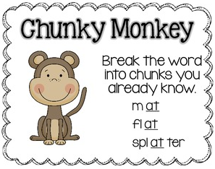­­

News from the 1/2s

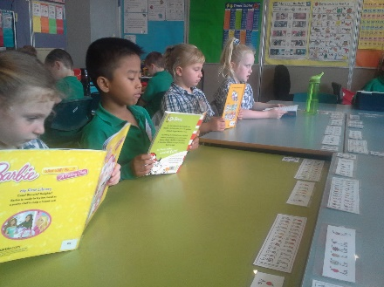

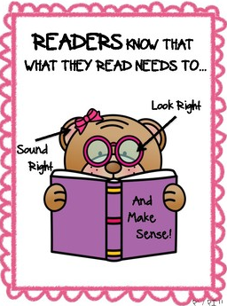**Term 1 - Weeks 6 and 7!**

**In Reading:**

In Weeks 6 and 7 we have been improving our reading STRATEGIES by using the CHUNKY MONKEY (looking for smaller chunks in longer words) and deliberately listening to what we read to see if it MAKES SENSE! This week (Tues 12th Mar) we are exploring how ABORIGINAL LEGENDS are written, and discussing what they are trying to explain. This is part of a broader unit looking at LEGENDS, FABLES and FAIRY TALES

**In Writing:**

After reading FAIRY TALES over the past few weeks, what could be better than writing our own! We have re-written known fairy tales and explored our own ideas. We have been using different sentence beginnings like ONOMATOPOEIA (sounds) and DESCRIPTION. Our published NARRATIVES will be placed on the ‘Writing Wall’ at the end of the term.

**In Mathematics:**

Addition has been the focus concept for weeks 6 and 7, with students working on the concepts of:

* Ordering numbers from LARGEST TO SMALLEST before adding (eg 5+12 is turned into 12+5= and then added);
* COUNTING ON when using abacus (eg starting at 12 and then counting 5 more on, rather than counting to 12 to begin with); and
* DIFFERENTIATING numbers before adding (15 + 12 is easier to add as 10+10+5+2)

**Same, But Different!**

Our Integrated Unit (understanding the differences between CULTURES) has recently focused on family backgrounds and names. This week we will be looking closely at the origin of foods from across the world.

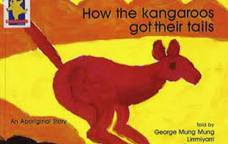



**COOKING: What’s on the menu?**

Week 7 – Chocolate Slice

Week 8 – Zucchini Slice

Week 9 – Banana Bread

**A HUGE thank you** to all the parents and grandparents who have already helped with cooking this term! ☺

**UPCOMING EVENTS:**

**School Photos** - March 19th

**Last Day of Term 1** – April 5th - 2:30 Dismissal

Th

**NOTE ABOUT… Learning at Home:**

A big thank you for your support of the home readers! Please remember to keep working hard learning the **Magic100** Reading Words and **Oxford** Spelling Words – It really pays off!

**MATIFIC** and **READING EGGS** – If you did not receive your Matific or Reading Eggs / Eggspress password in your child’s reader, please contact your teacher ASAP – These are fantastic resources to support your child’s learning.

**Please ask us to show you how!**