Lava Pizza Rolls
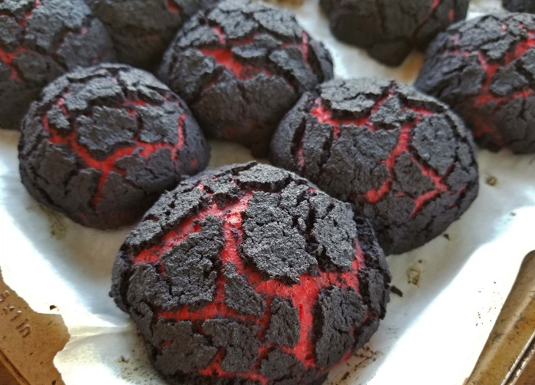
(makes 6)

INGREDIENTS

Pizza Roll

- 1 packet Rest and Roll Pizza Dough
(or use your own favourite pizza dough recipe)
- 1 tsp Red gel food colouring
- A little plain flour for kneading
- Pizza fillings of choice (we used basil paste, bocconcini cheese, capsicum and ham)

Crackle Topping

- 1 Tbs active dry yeast
- ½ cup warm water
- ½ tsp Black gel food colouring
- 1 Tbs caster sugar
- 1 Tbs Vegetable oil
- ¾ cup Rice flour
METHOD
Pizza Roll
- Preheat oven to 180°C and line a baking tray with baking paper.
- Lightly dust benchtop with flour and knead red colouring into pizza dough.
- Spray a mixing bowl with cooking spray, place dough into bowl and allow to sit in a warm place for 1 hour.
- Split dough into 6 equal portions and stretch out into small disks.
- Fill each disk with pizza toppings of choice. Stretch edges of dough over the filling to seal them inside and place on prepared tray, seam side down.
Crackle Topping
- Mix all crackle topping ingredients together in a bowl, either by hand or using an electric beater, until smooth. This mix should be thick and sticky but still fluid enough to slowly ooze and drip off the spoon or beater.
- Paint a thin layer of crackle topping over the top of each pizza roll so no red is showing. For best results allow to sit for 15 minutes.
- Bake for 10-15 minutes or until bottoms of rolls are dry when tapped lightly.
Enjoy

Note: To make Halloween theme, try leaving the colouring out of the topping mix and placing a slice of stuffed olive on top after cooking to look like a bloodshot eye.

