Mint Yoghurt
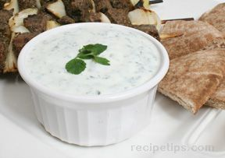
Ingredients:
• 2 cups natural yoghurt
• 2 cloves garlic
• ¾ cup chopped mint
• 4 tablespoons lemon juice
• Pinch of salt (to taste)

What to Do:
• Wash and finely chop the mint leaves
• Peel and crush the garlic into a bowl and pour over the lemon juice and
sprinkle over some salt. Leave to stand for a couple of minutes.
• Mix the yoghurt, garlic, lemon juice, salt and chopped mint until combined.
Taste and add salt or more lemon juice if necessary.
• Serve the mint yoghurt on the plates with the pizza and couscous.

