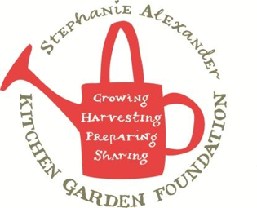

Bok Choy Frittata
Season: All Serves: 2 frittatas (32 tastes)
Difficulty: Easy From the garden: Bok Choy, Seasonal Vegetables
Allergy advice: contains eggs, dairy (cream), wheat/soy (ketjap manis)
Take out a spoonful of stir-fry mix prior to adding eggs and dairy, kids can try vegetables with some gluten free oyster sauce drizzled over.

Equipment:  - Knives  - Chopping Boards  - Large Frying pan  - bowl  - whisk  - measuring jug  - Wooden spatula | Ingredients:  - 1 tablespoon oil  - 2 cloves garlic  - 250g garden vegetables – beans, eggplant, capsicum, zucchini etc.  - 1 bunch bok choy  - 1 cup bean sprouts  - 1 cup chopped silverbeet/kale  - 10 eggs  - 1 ½ cups cream  - ketjap manis soy sauce to serve

What to do:
- Finely chop garlic
- Chop garden vegetables into small pieces.
- Chop stems and leaves of Bok Choy.
- Slice silverbeet and kale stems and leaves finely.
- Whisk eggs and cream together.
- Heat Grill to 200 degrees
- Heat large frying pan with oil, add garlic and garden vegetables, sauté for 3-4 minutes or until onions are soft.
- Add bok choy, bean sprouts and silverbeet/kale.
- Heat second frying pan with oil and then divide mixture evenly between 2 frying pans.
- Pour over egg and cream mix and cook over a medium/low heat until egg begins to set.
- Finish off cooking of frittata under the grill until golden brown.
- Flip frittata out and drizzle with ketjap manis.
- Cut into pieces to serve.

