Rice Pilaf with leeks
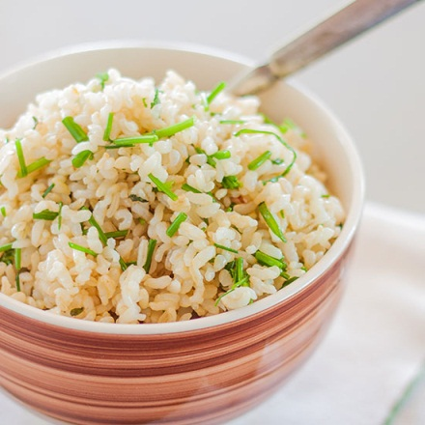
2 cloves garlic, minced
4 Tbsp. olive oil
2 medium leek, pale and green part only, halved lengthwise, washed and thinly sliced
4 cups long grain white rice
2 tsp. dried or fresh tarragon (finely chopped)
1.75 litres chicken or vegetable stock
Salt and white pepper to taste
2 Tbsp. chopped fresh parsley

Method:
- Prepare all vegetables, herbs and other ingredients, etc.
- Place oil in a pot over medium heat. Add the leek and garlic and cook until tender, about 6 to 7 minutes.
- Mix in the rice and tarragon. Add the stock and increase the heat, bring to a boil.
- Once it boils, cover, and turn the heat to its lowest setting. Cook 15 minutes, or until the rice is tender. Mix in the chopped parsley and serve.

