Roast capsicum hommus
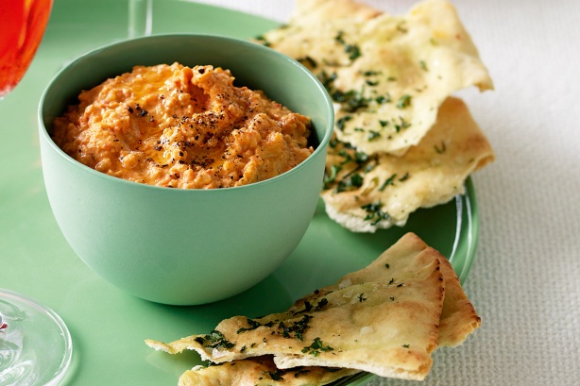
- 2 x 400g can chickpeas, drained, rinsed
- 3 tablespoons tahini
- 4 tablespoons lemon juice
- 2 garlic clove, quartered
- 1 cup chopped chargrilled capsicum ( 4 whole capsicum’s)
- 4 tablespoons olive oil

Step 1 Coat capsicum in olive oil and salt and pepper. Cook on grill plate until blackened all over.
Place capsicum in metal bowl and cover with glad wrap. Leave for 10 minutes.
Peel Capsicum and remove seeds. Roughly chop capsicum.

Step 1 Process chickpeas, tahini, lemon juice, garlic and capsicum until smooth. Season with salt and pepper.
Add olive oil and 2 tablespoons cold water. Process until combined. Serve with pita bread crisps (see separate recipe)

