Rocket, basil and kale pesto

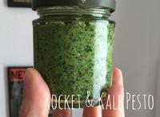

- 2 bunch roquette, coarsely chopped
- 1 cup basil leaves
- 1 cup kale leaves
- 3 garlic cloves, crushed
- 1 cup parmesan, finely grated
- 1 cup (125ml) olive oil

Step 1
Wash Roquette leaves, basil leaves and kale leaves and drain well. Remove all the leaves from their stalks. Peel and crush garlic.

Step 2
Grate parmesan until you have 1 cup. Place the roquette, basil, kale, crushed garlic and parmesan in the bowl of the food processor and process until finely chopped. With the motor running, add the oil in a thin, steady stream and process until well combined. Season to taste.

